CST8912 – Cloud Solution Architecture
Graded Lab Activity #8
Introduction:
Managing cloud resources effectively is essential for maintaining an organized, compliant, and secure cloud environment. Tagging resources is a key aspect of cloud governance, providing a mechanism to label and categorize resources for better visibility, management, and compliance. It plays a critical role in ensuring that resources are efficiently utilized and aligned with organizational policies. In this hands-on lab, you will explore how tagging can be implemented and enforced in Azure to strengthen compliance with governance frameworks and optimize resource management.
Objective:
The objective of this lab is to understand the principles of cloud governance through effective tagging and policy enforcement in Azure. By the end of this lab, we will be able to:
- Create and assign tags to resources via the Azure portal.
- Enforce tagging policies using Azure Policy.
- Apply automated tagging policies for resource compliance.
- Configure and test resource locks to prevent unintended changes.
- Clean up and manage resources for optimal organization and compliance.

Task 1: Assign tags via the Azure portal
- Sign in to the Azure portal - https://portal.azure.com.
- Search for and select Resource groups.
Setting | Value
Subscription name | your subscription
Resource group name | CST8912
Location | Canada Central
- From the Resource groups, select + Create.
- Note
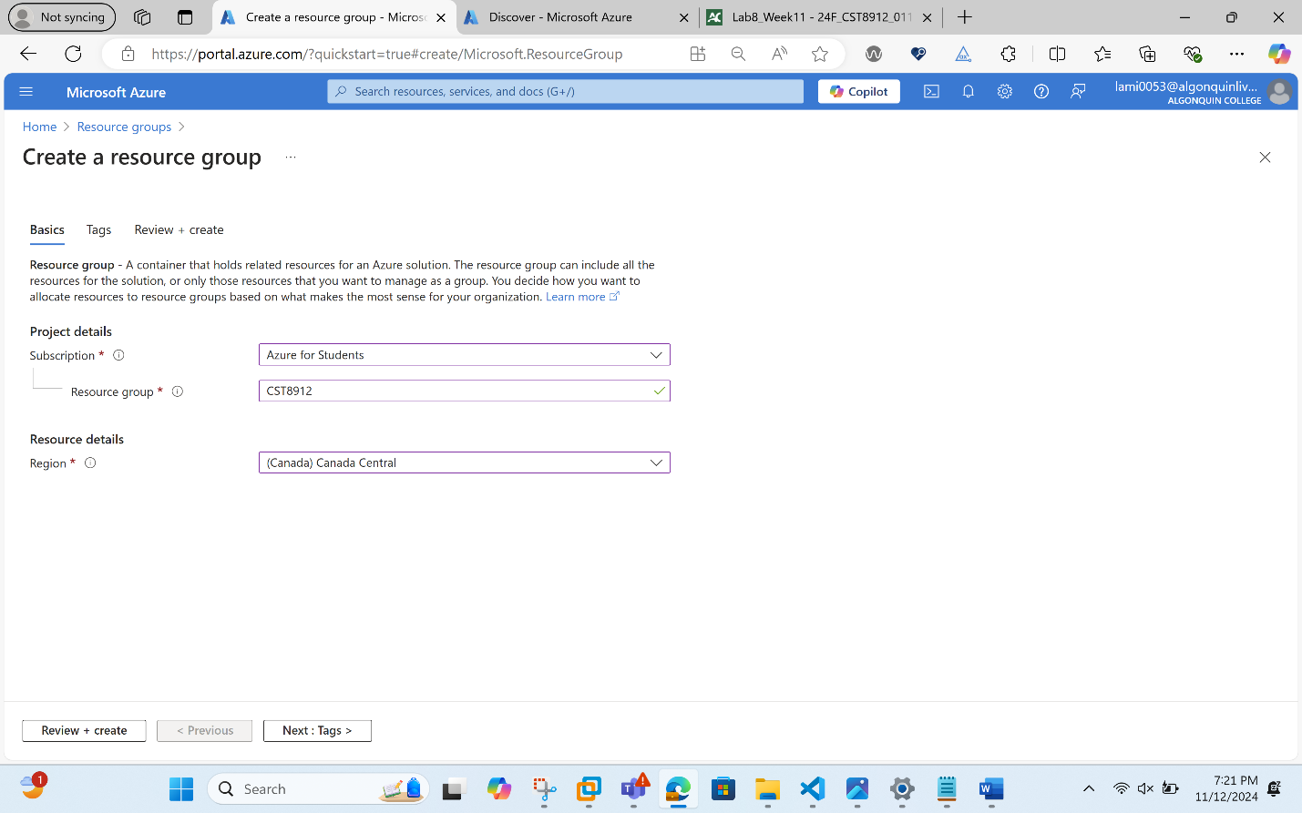
- Select Next: Tags and create a new tag.
Setting | Value
Name | Cost Center
Value | 000
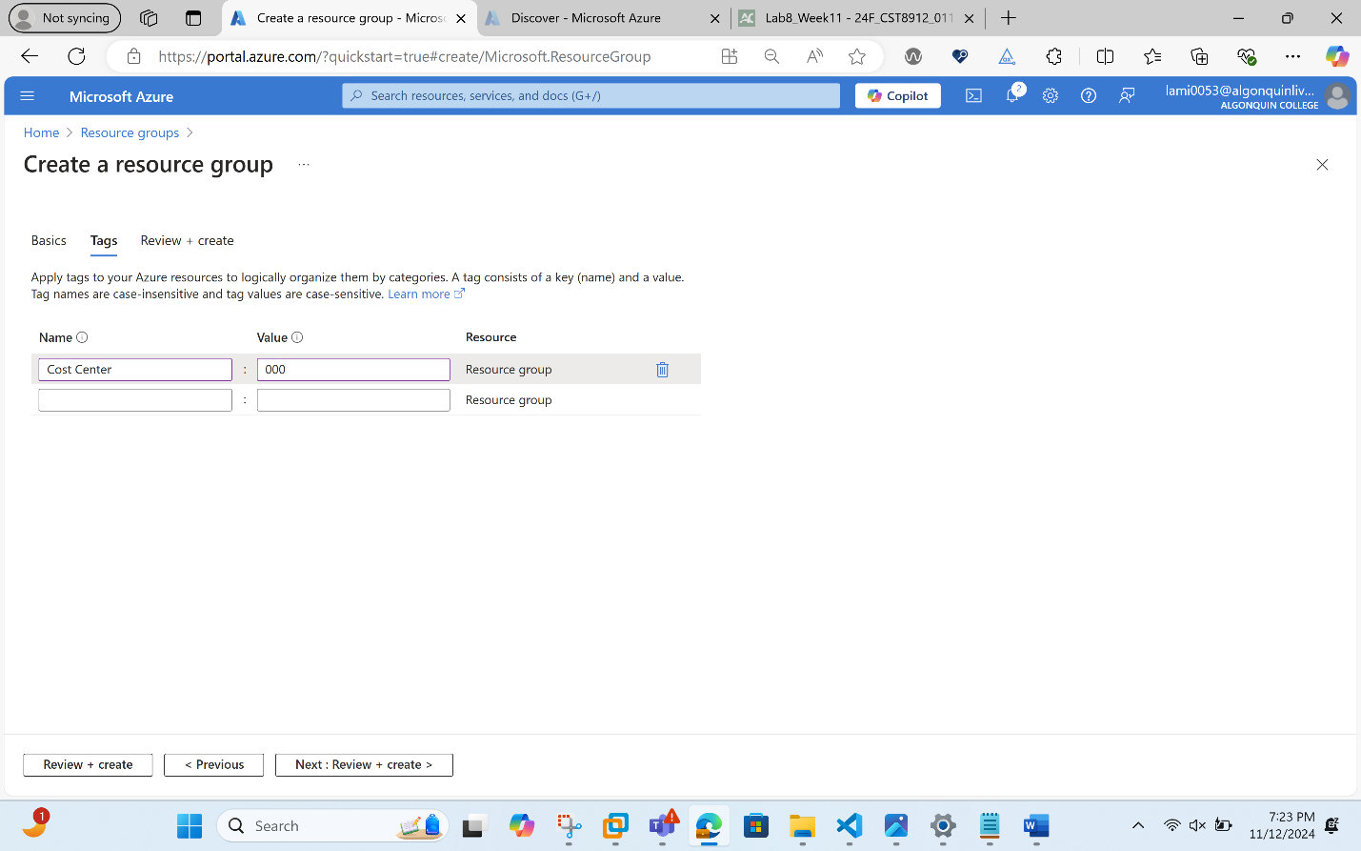
- Select Review + Create, and then select Create.
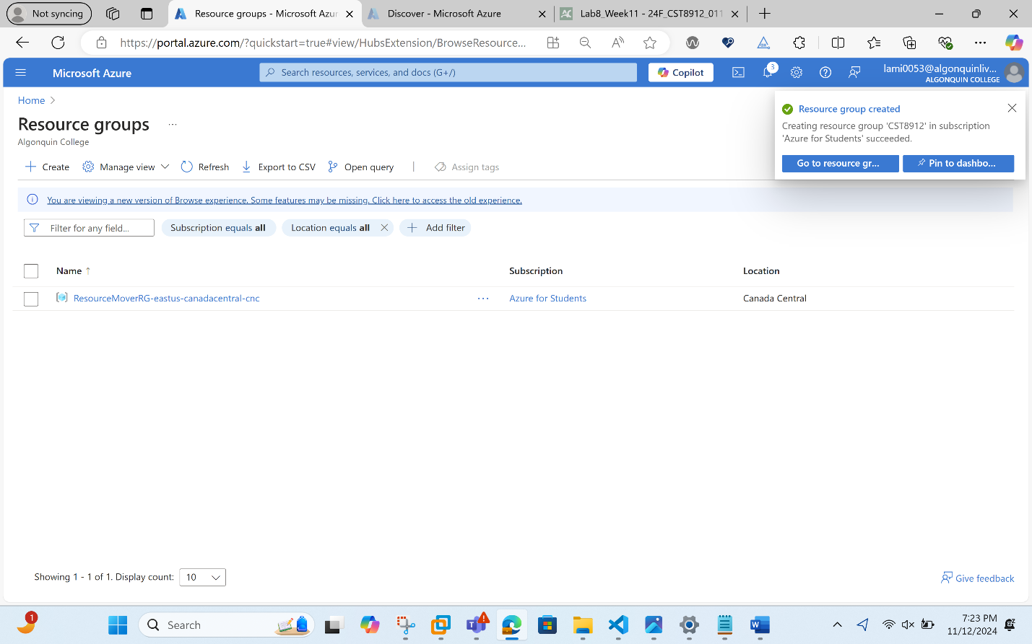
Task 2: Enforce tagging via an Azure policy
- In the Azure portal, search for and select Policy.
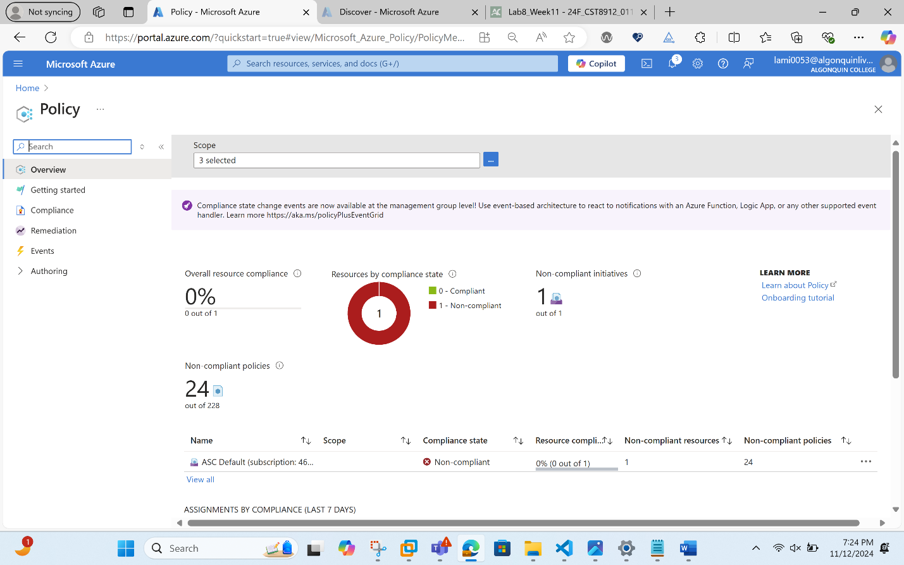
- In the Authoring blade, select Definitions. Take a moment to browse through the list of built-in policy definitions that are available for you to use. Notice you can also search for a definition.
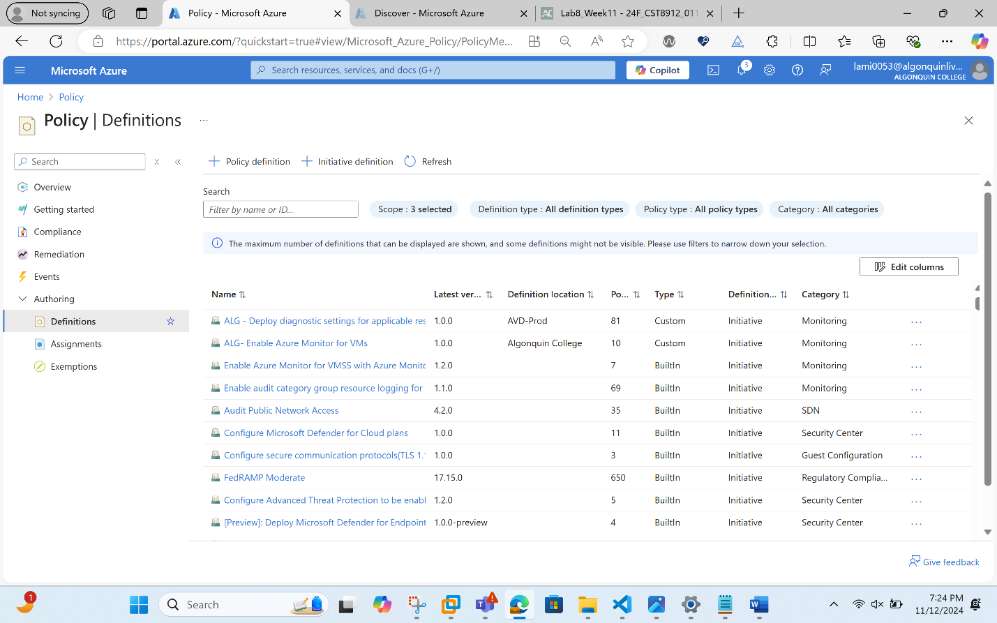
- Search for “require a tag”
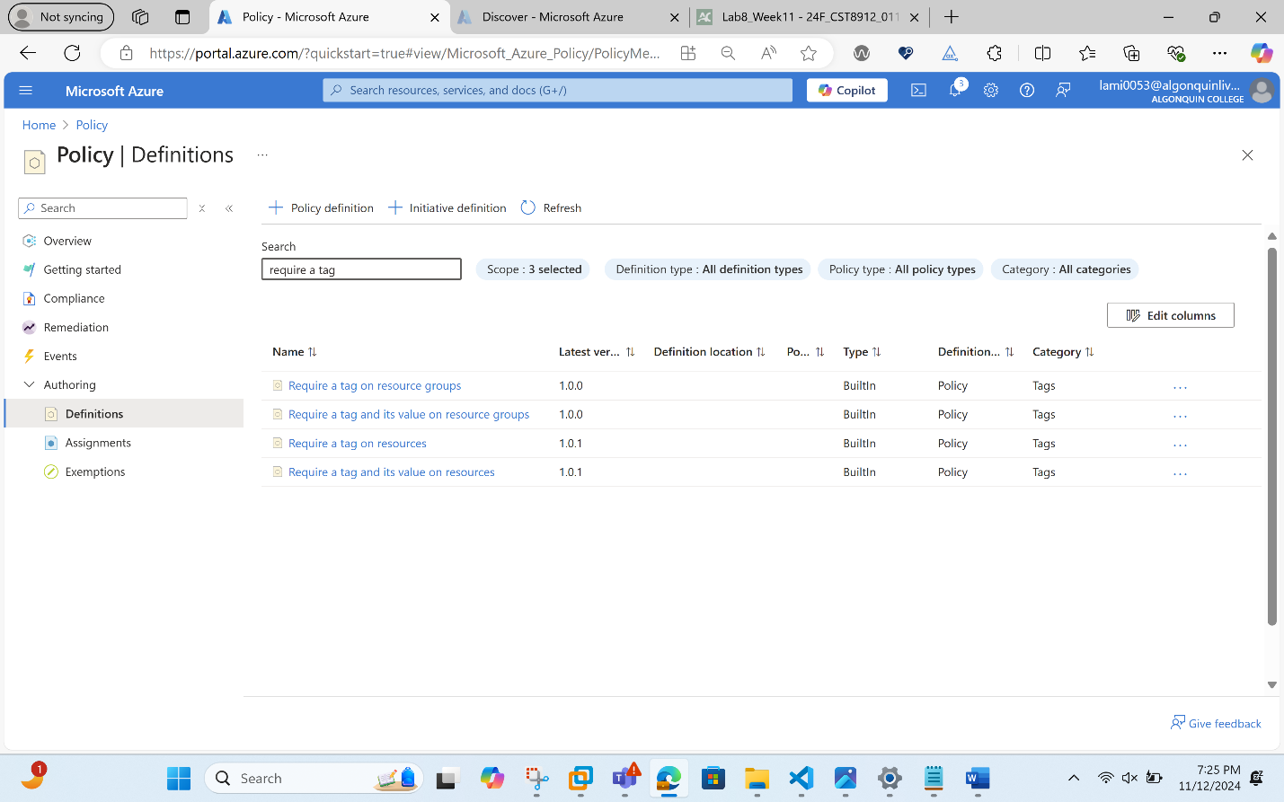
- Screenshot of the policy definition.
- Click the entry representing the Require a tag and its value on resources built-in policy. Then click Assign on the Require a tag and its value on resources built-in policy definition blade.

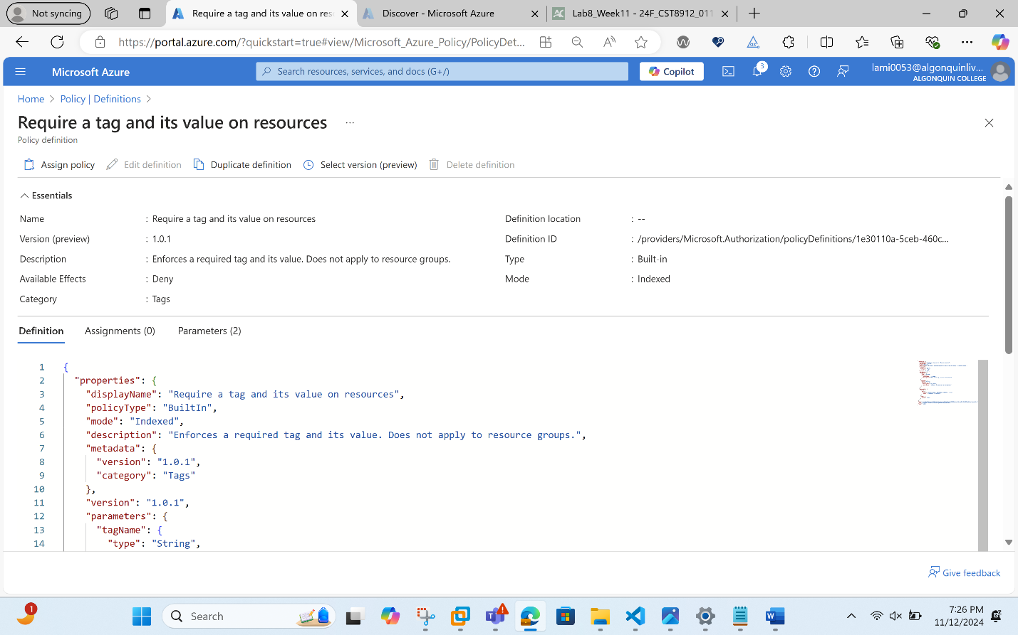
- Specify the Scope by clicking the ellipsis button and selecting the following values. Click Select when you are done.
Setting | Value
Subscription | your subscription
Resource Group | CST8912
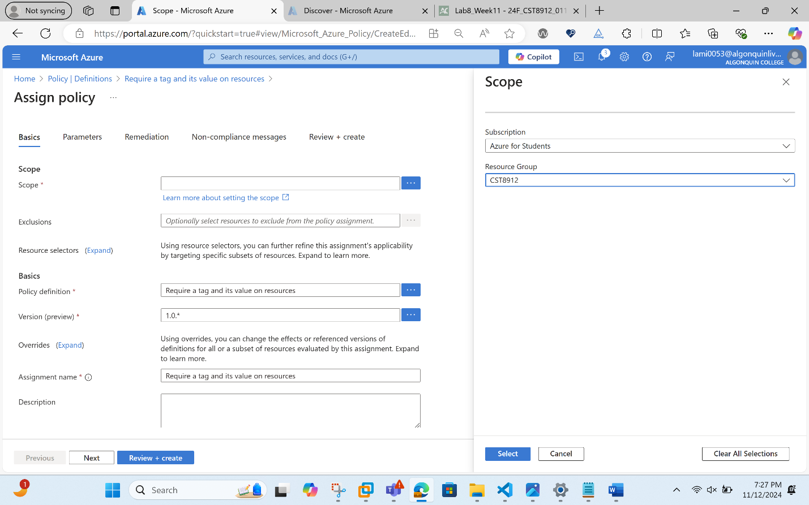
- Configure the Basics properties of the assignment by specifying the following settings (leave others with their defaults):
Setting | Value
Assignment name | Require Cost Center tag with Default value
Description | Require Cost Center tag with default value for all resources in the resource group
Policy enforcement | Enabled

- Note:

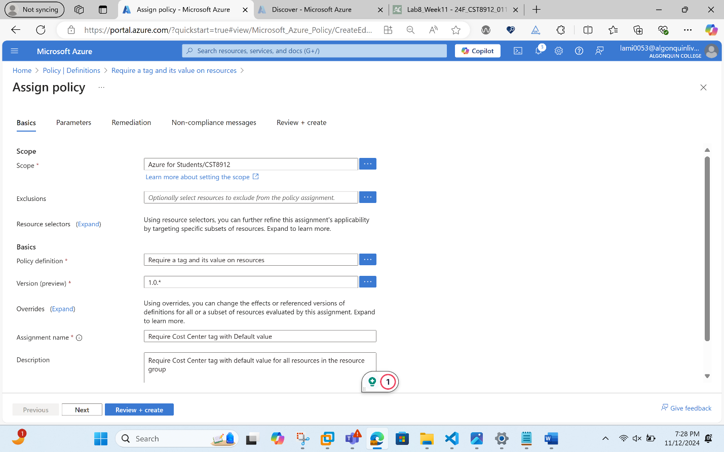
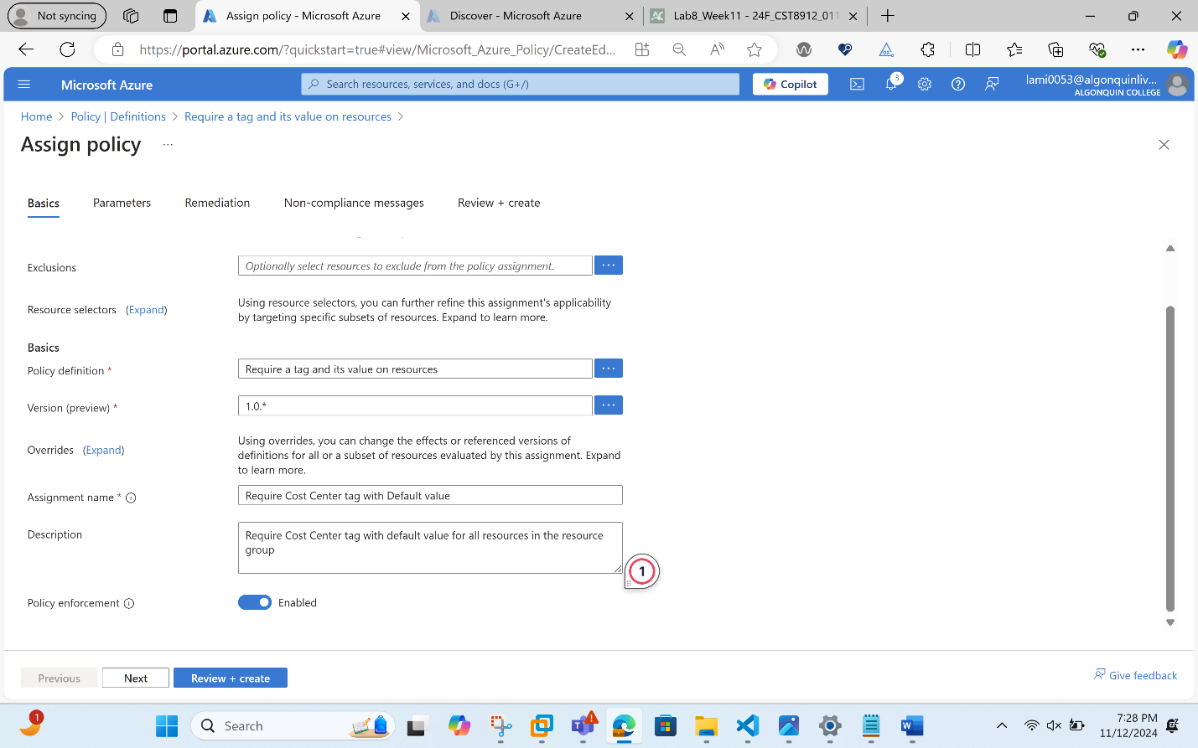

- Click Next twice and set Parameters to the following values:
Setting | Value
Tag Name | Cost Center
Tag Value | 000

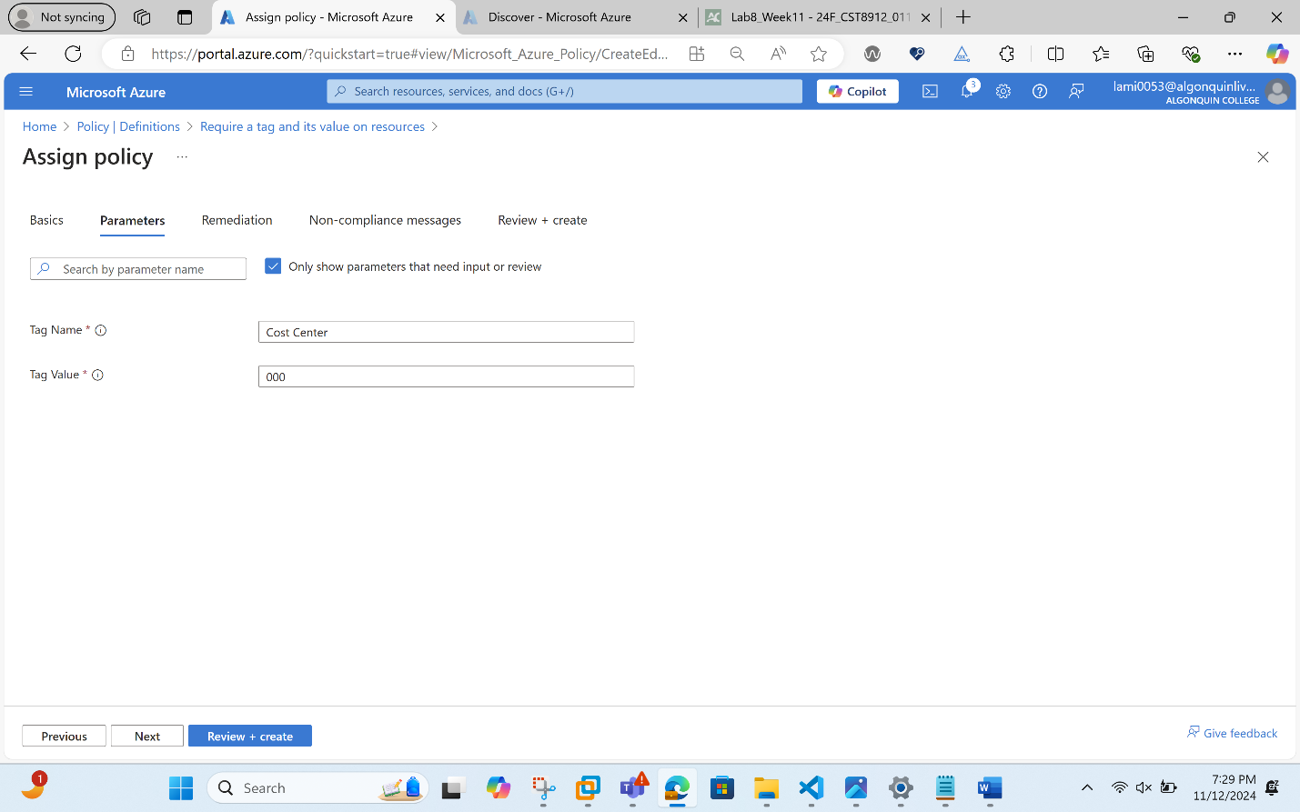
- Click Next and review the Remediation tab. Leave the Create a Managed Identity checkbox unchecked
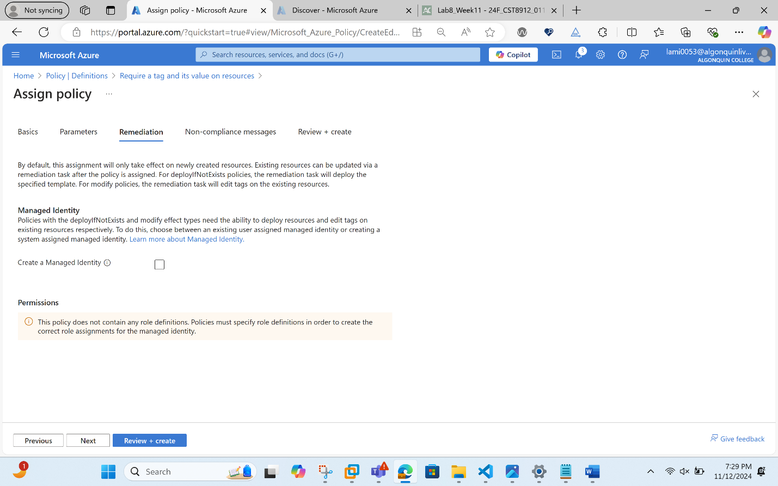
- Click Review + Create and then click Create.
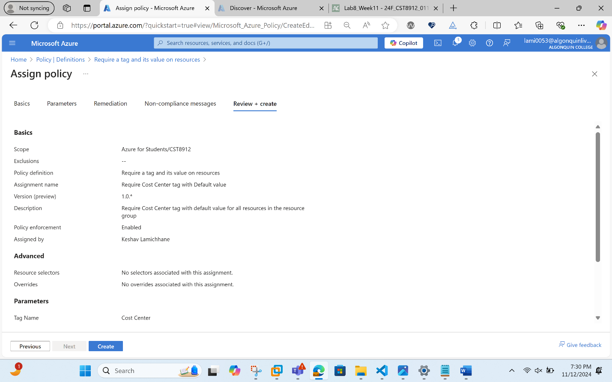
- Note: Now you will verify that the new policy assignment is in effect by attempting to create an Azure Storage account in the resource group. You will create the storage account without adding the required tag.
- Note: It might take between 5 and 10 minutes for the policy to take effect.
- In the portal, search for and select Storage Account, and select + Create.
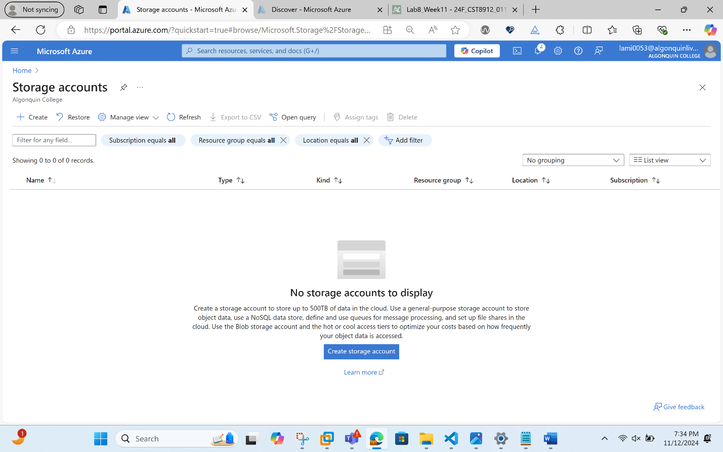
- On the Basics tab of the Create storage account blade, complete the configuration.
Setting | Value
Resource group | CST8912
Storage account name | any globally unique combination of between 3 and 24 lower case letters and digits, starting with a letter

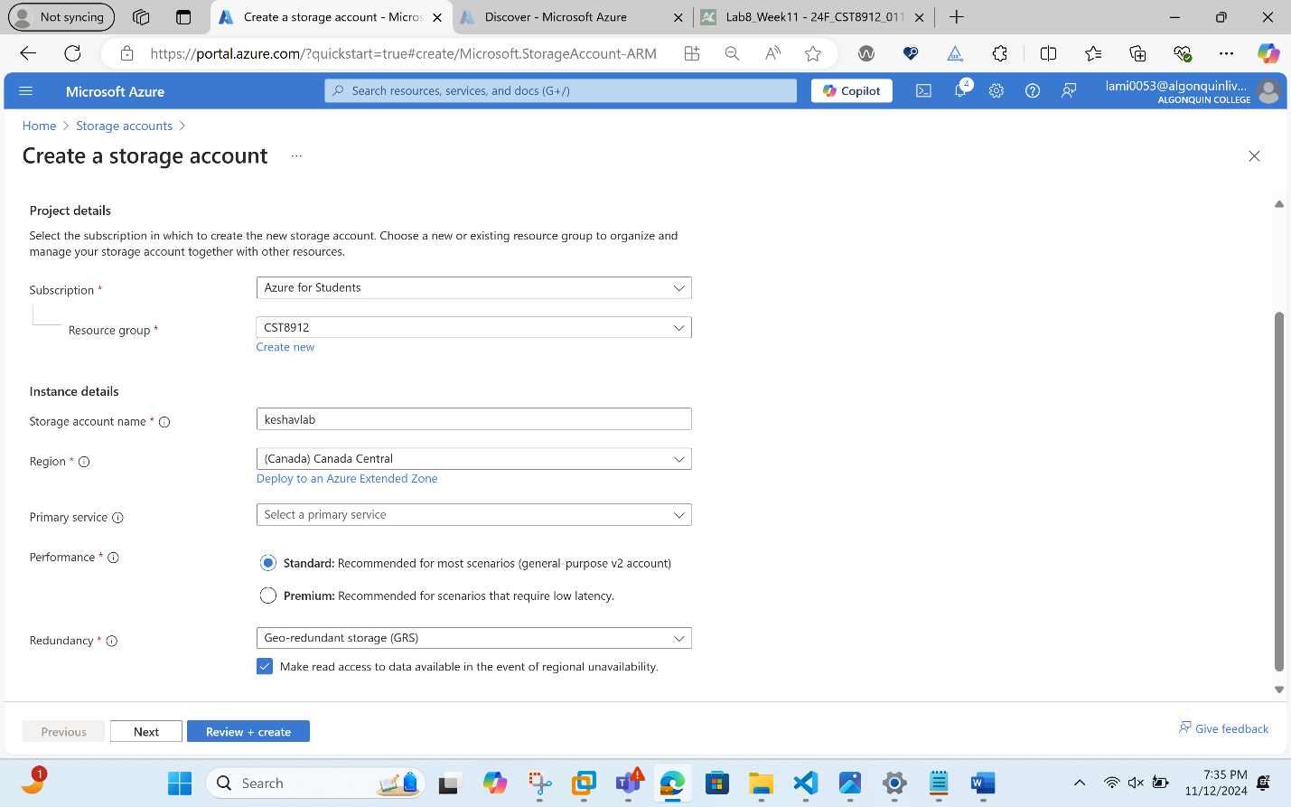
- Select Review and then click Create.
- You should receive a Validation failed message. View the message to identify the reason for the failure. Verify the error message states that the resource deployment was disallowed by the policy.
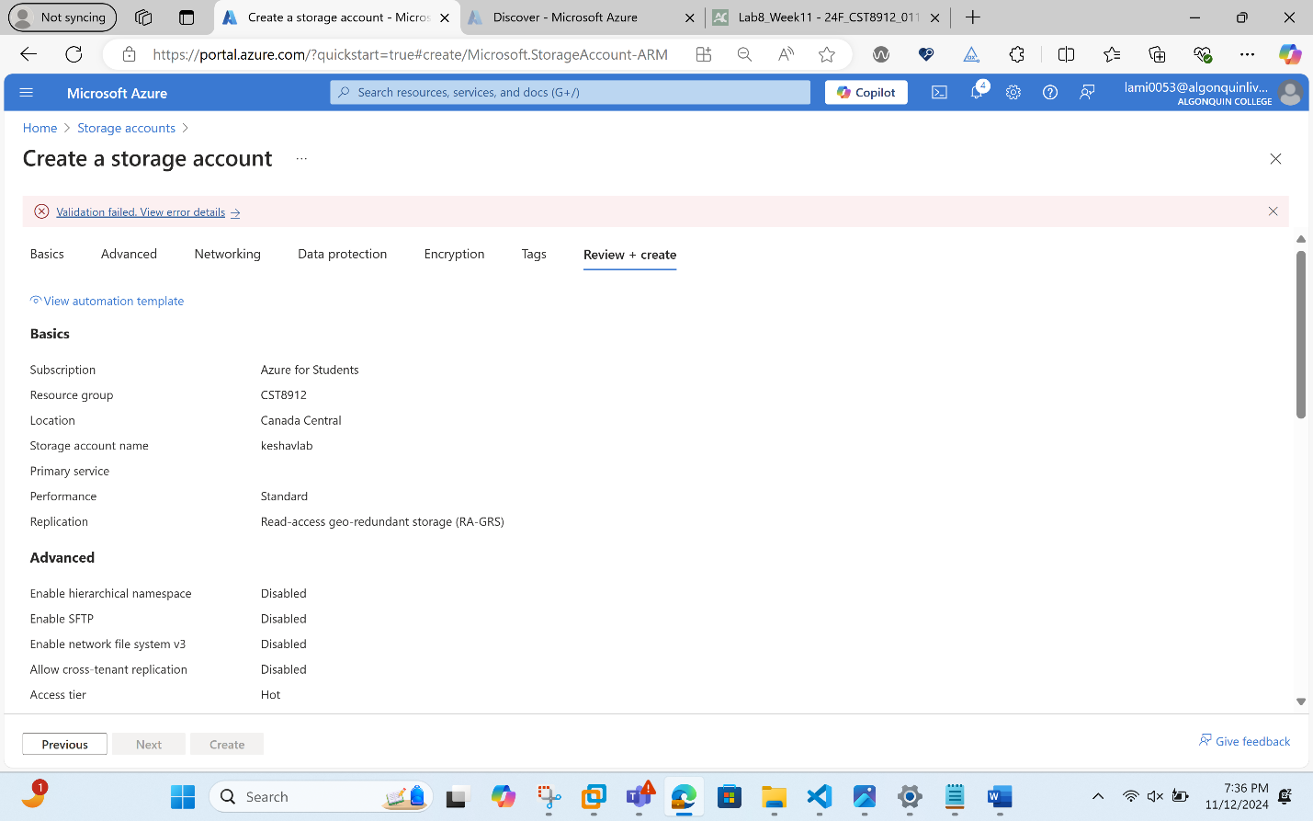
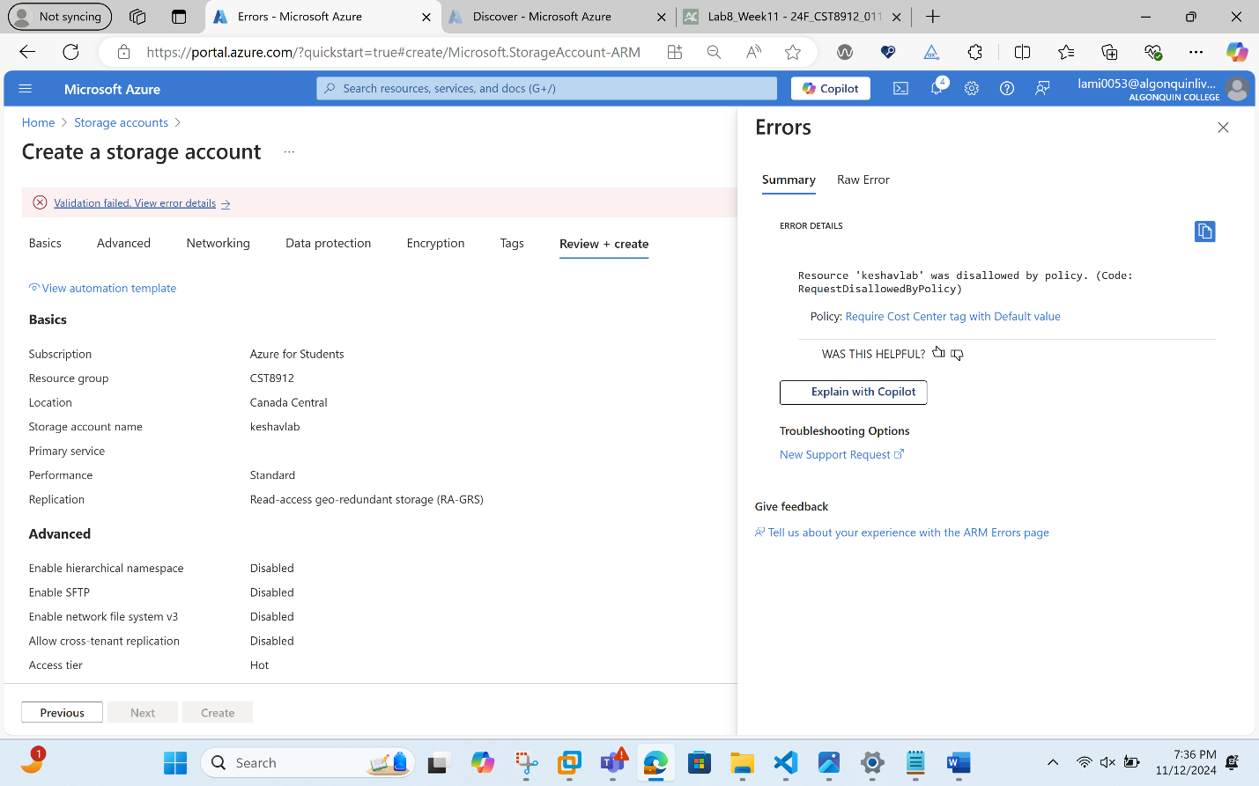
Task 3: Apply tagging via an Azure policy
- In this task, we will use the new policy definition to remediate any non-compliant resources. In this scenario, we will make any child resources of a resource group inherit the Cost Center tag that was defined on the resource group.
- In the Azure portal, search for and select Policy.
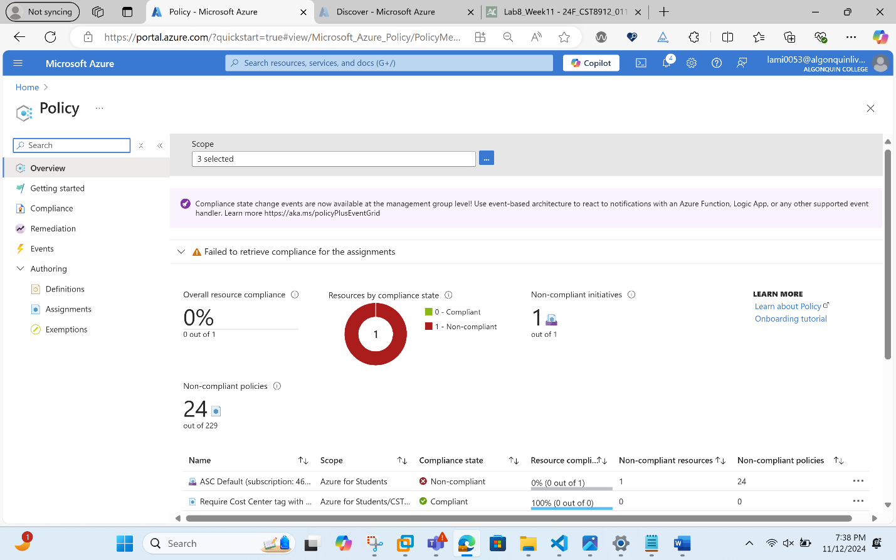
- In the Authoring section, click Assignments.
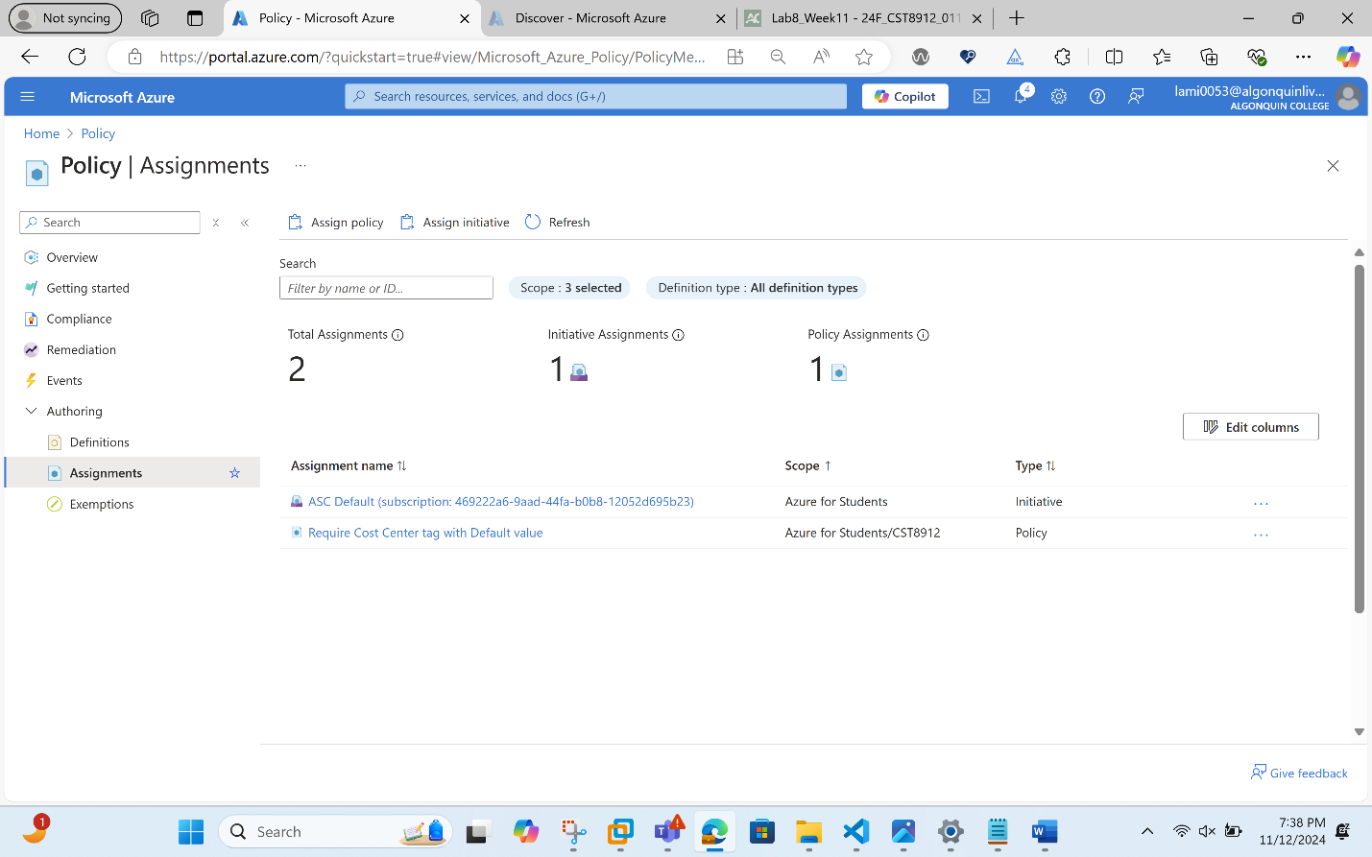
- In the list of assignments, click the ellipsis icon in the row representing the Require Cost Center tag with the Default value policy assignment and use the Delete assignment menu item to delete the assignment.
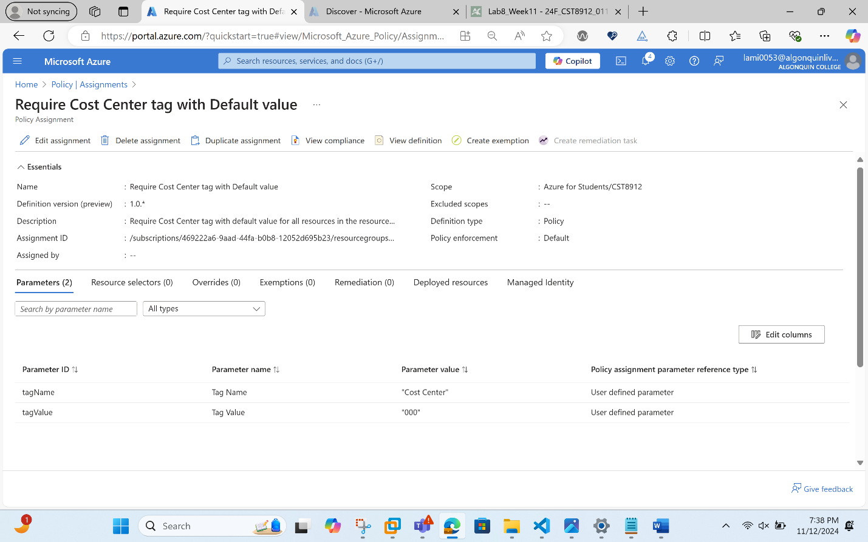
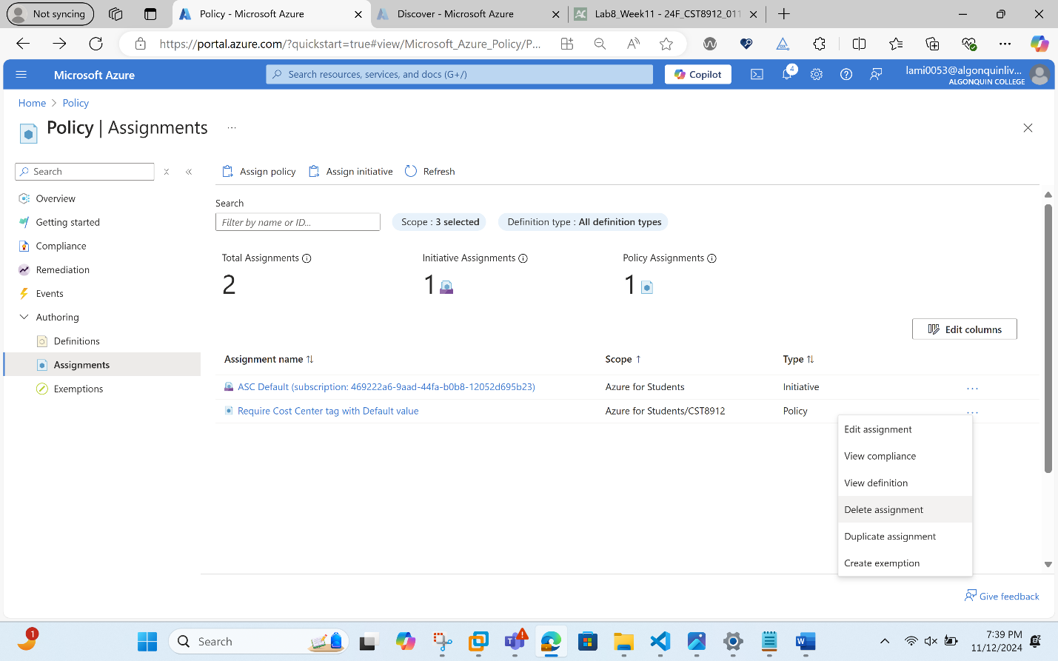
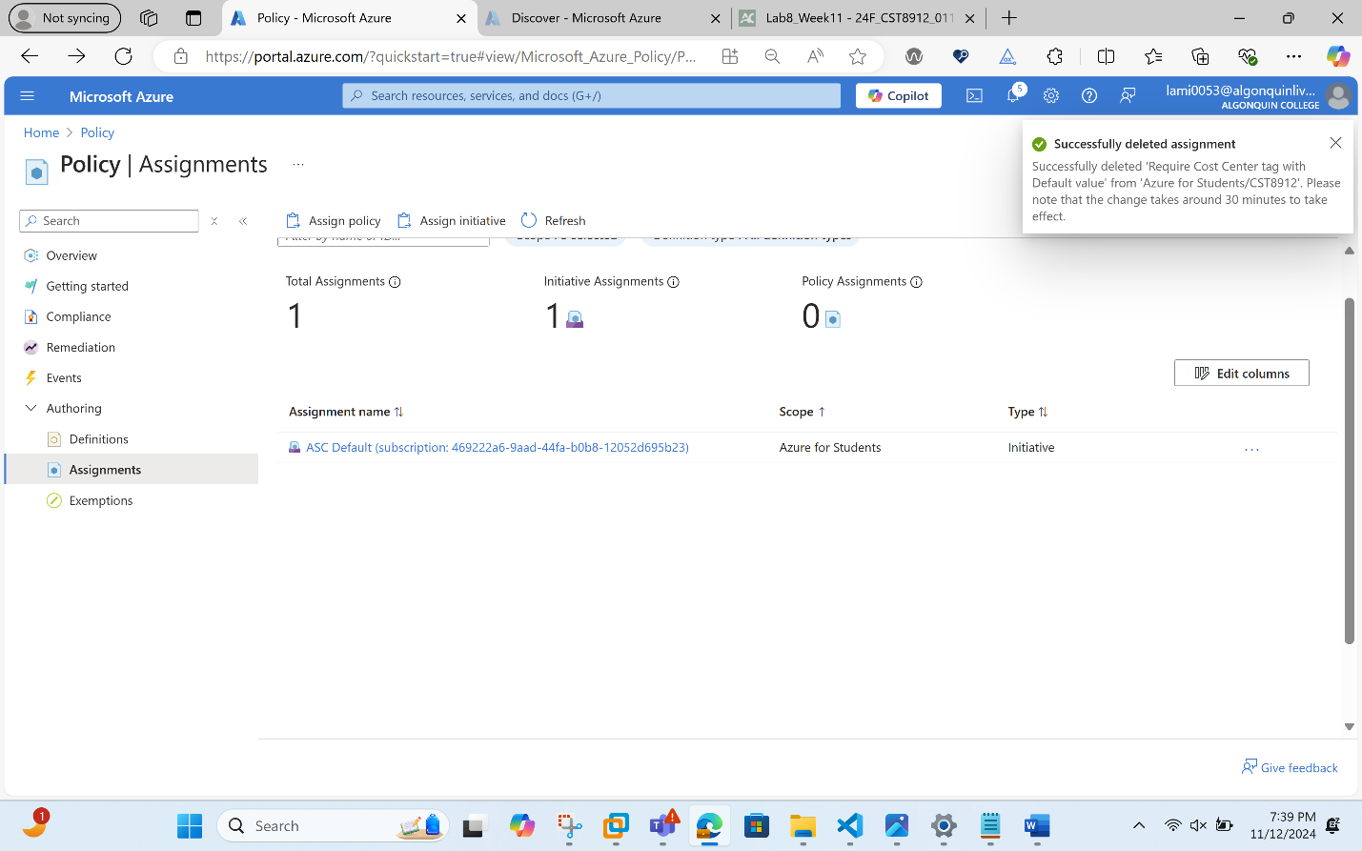
- Click Assign policy and specify the Scope by clicking the ellipsis button and selecting the following values:

Setting | Value
Subscription | your Azure subscription
Resource Group | CST8912
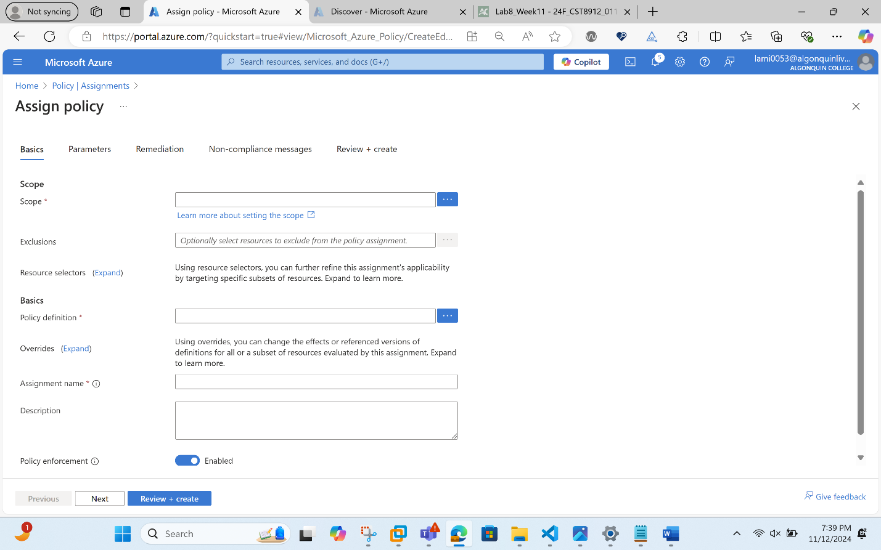
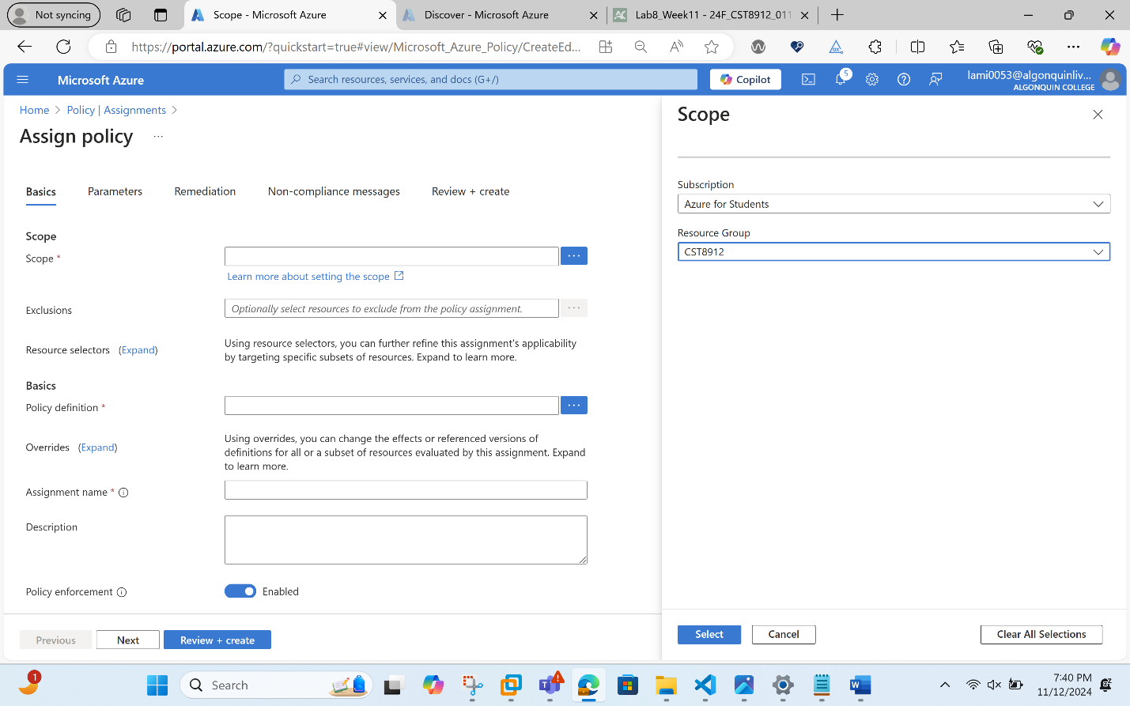

- To specify the Policy definition, click the ellipsis button and then search for and select Inherit a tag from the resource group if missing.
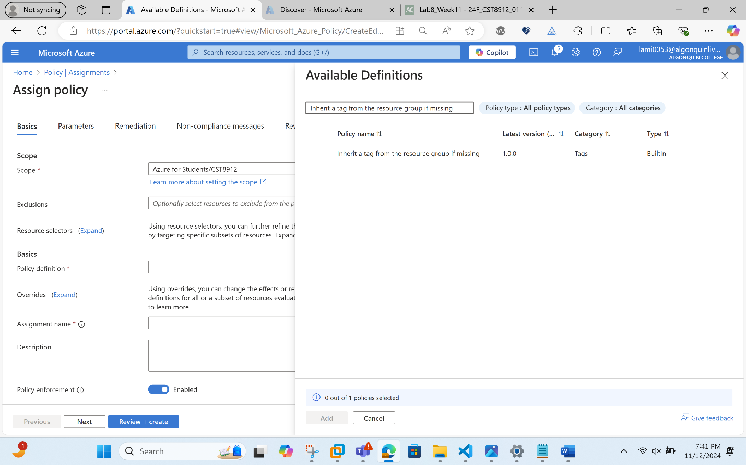
- Select Add and then configure the remaining Basics properties of the assignment.
Setting | Value
Assignment name | Inherit the Cost Center tag and its value 000 from the resource group if missing
Description | Inherit the Cost Center tag and its value 000 from the resource group if missing
Policy enforcement | Enabled
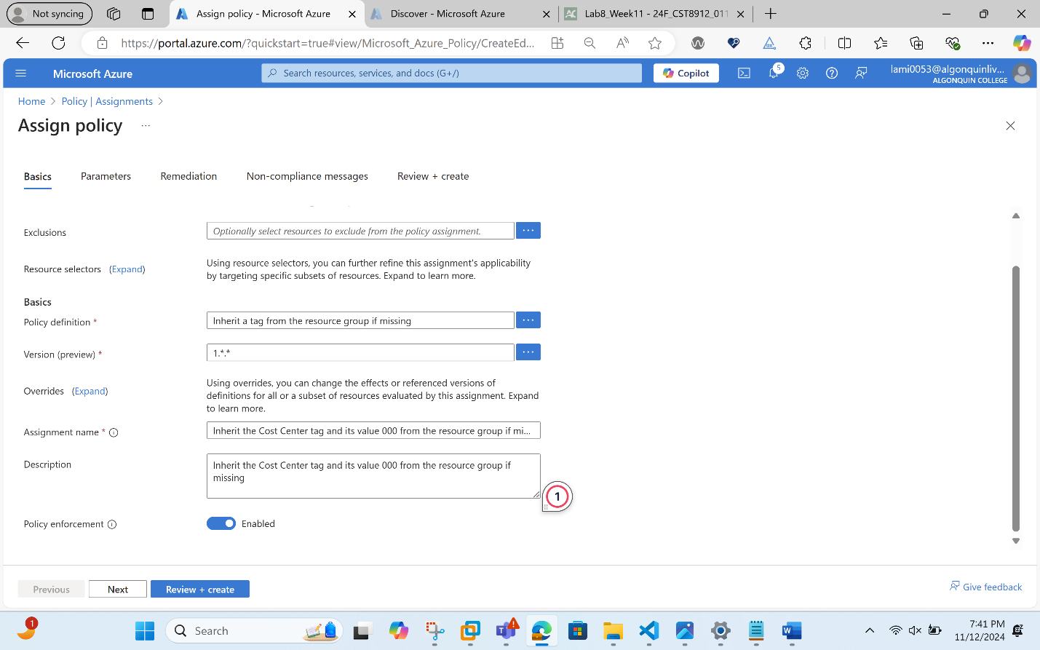
- Click Next twice and set Parameters to the following values:

Setting | Value
Tag Name | Cost Center
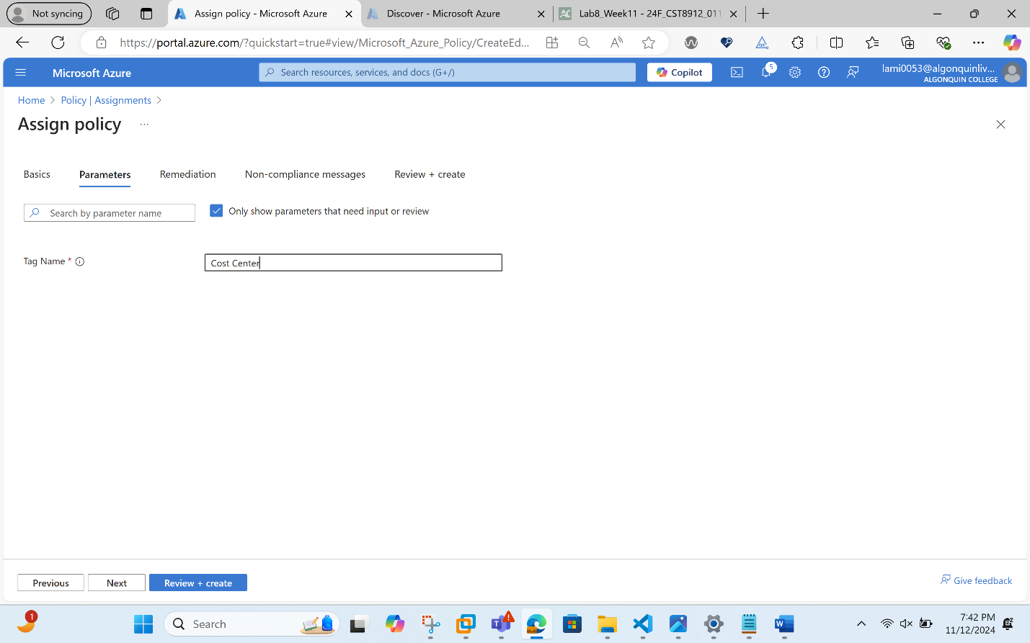
- Click Next and, on the Remediation tab, configure the following settings (leave others with their defaults):

Setting | Value
Create a remediation task | enabled
Policy to remediate | Inherit a tag from the resource group if missing

Then we take the Screenshot of the policy remediation page.
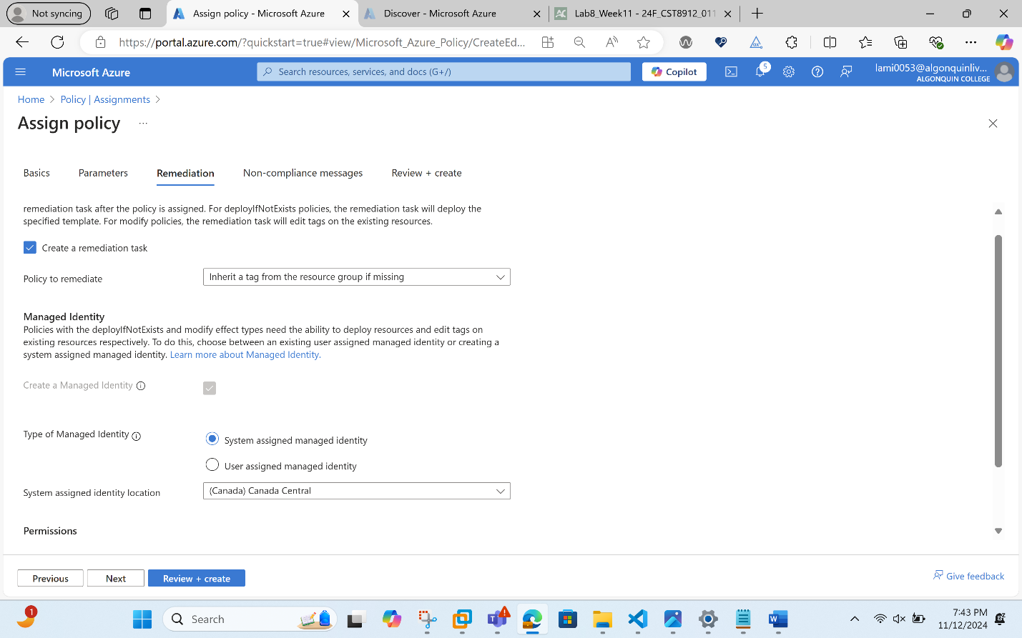
- Click Review + Create and then click Create.
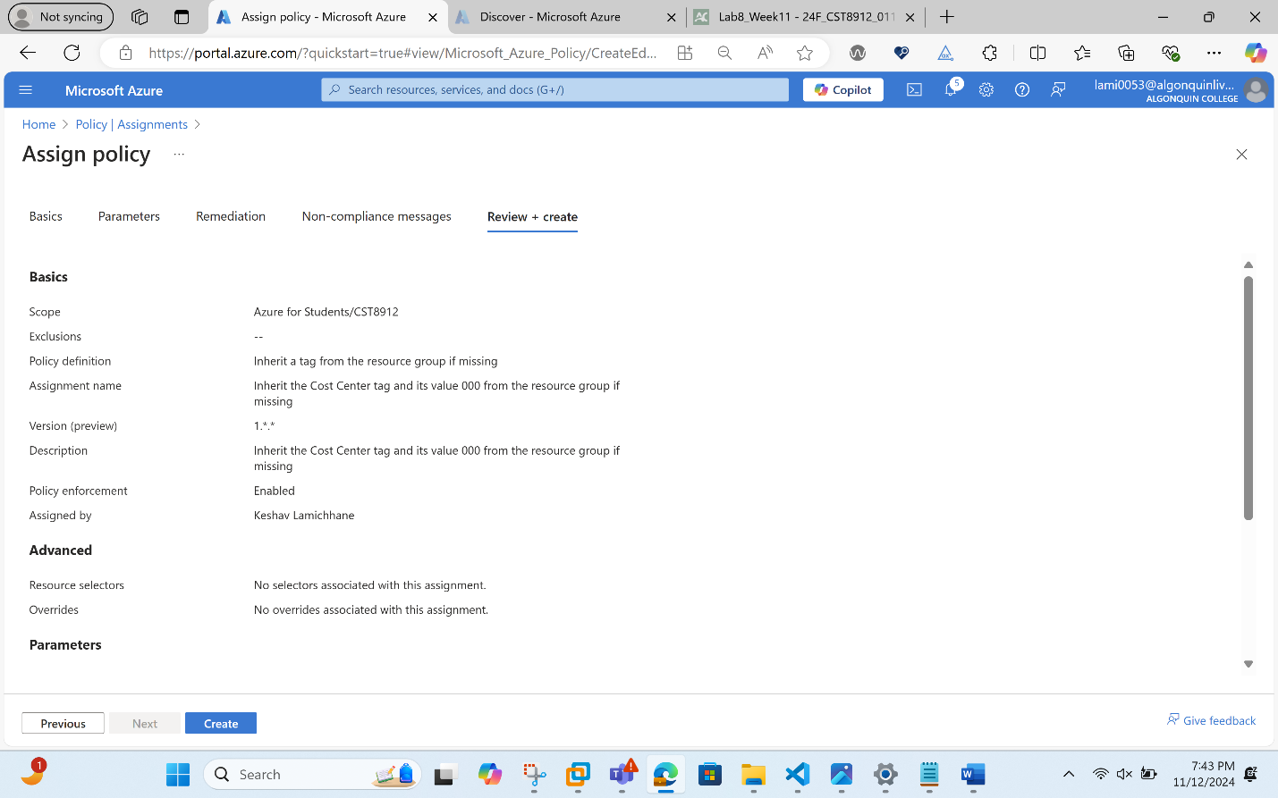
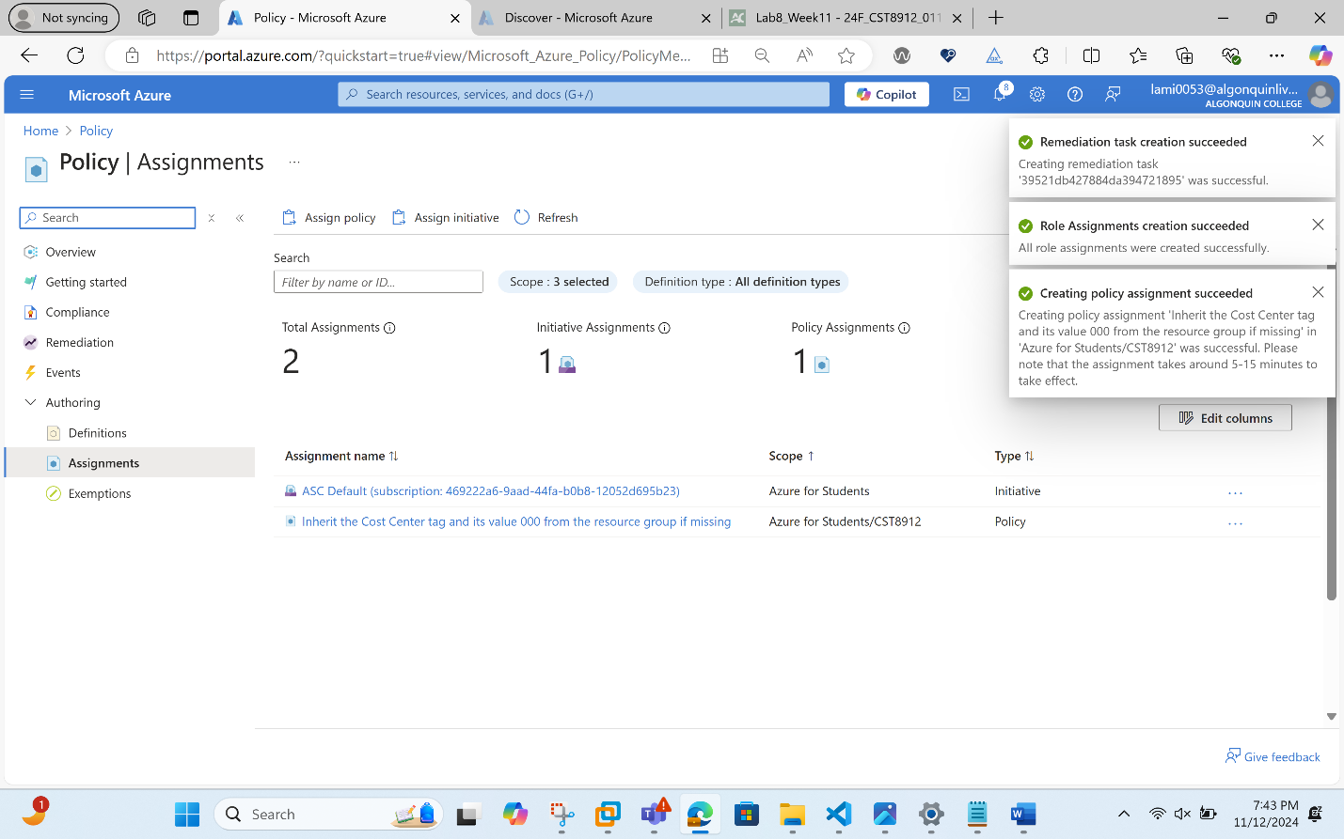
Note: To verify that the new policy assignment is in effect, you will create another Azure storage account in the same resource group without explicitly adding the required tag.
Note: It might take between 5 and 10 minutes for the policy to take effect.
Search for and select Storage Account, and click + Create.
- On the Basics tab of the Create storage account blade, verify that you are using the Resource Group that the Policy was applied to and specify the following settings (leave others with their defaults) and click Review:

Setting | Value
Storage account name | any globally unique combination of between 3 and 24 lower case letters and digits, starting with a letter
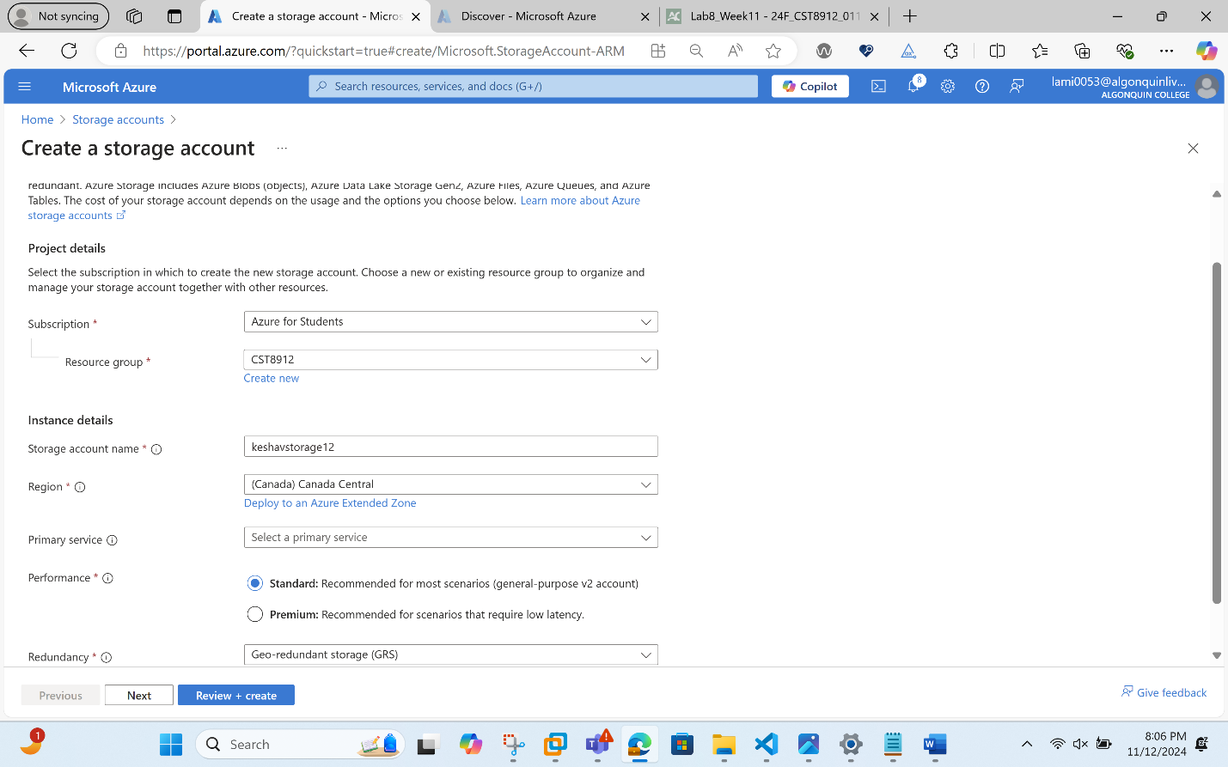
- Verify that this time the validation passed and click Create.
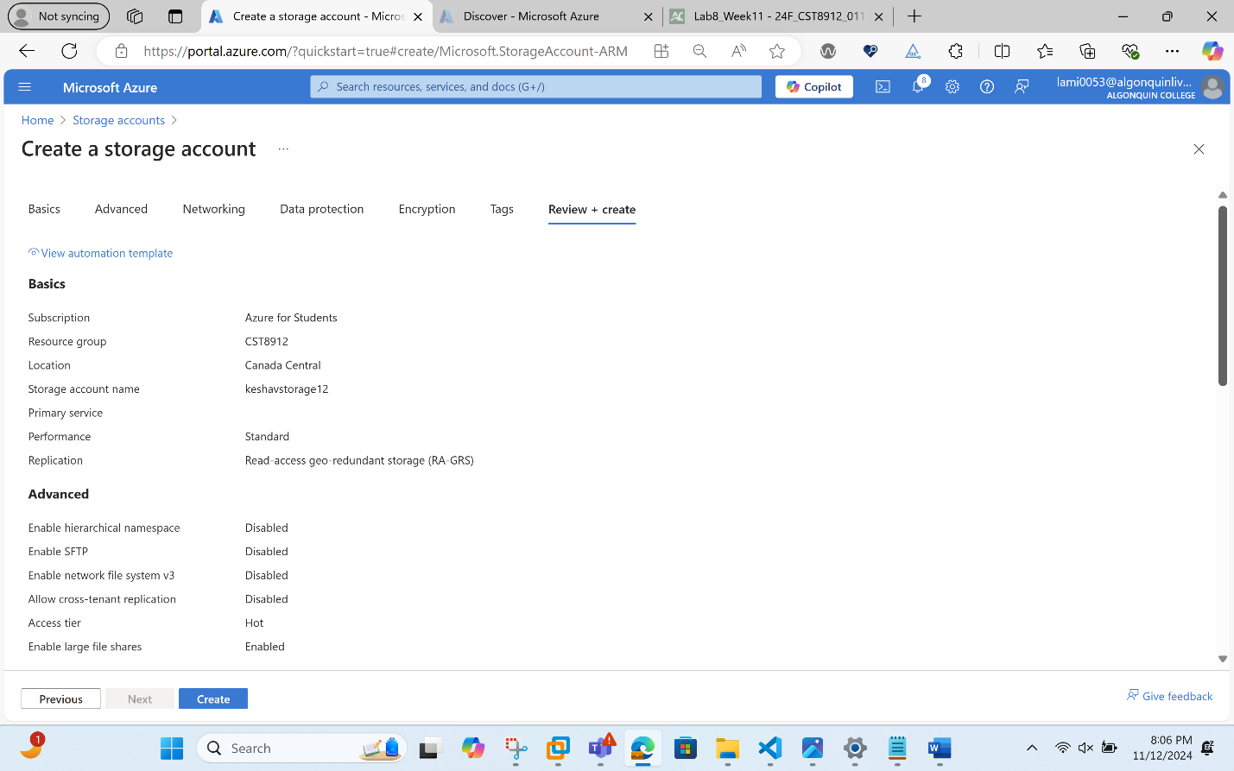
- Once the new storage account is provisioned, click Go to resource.
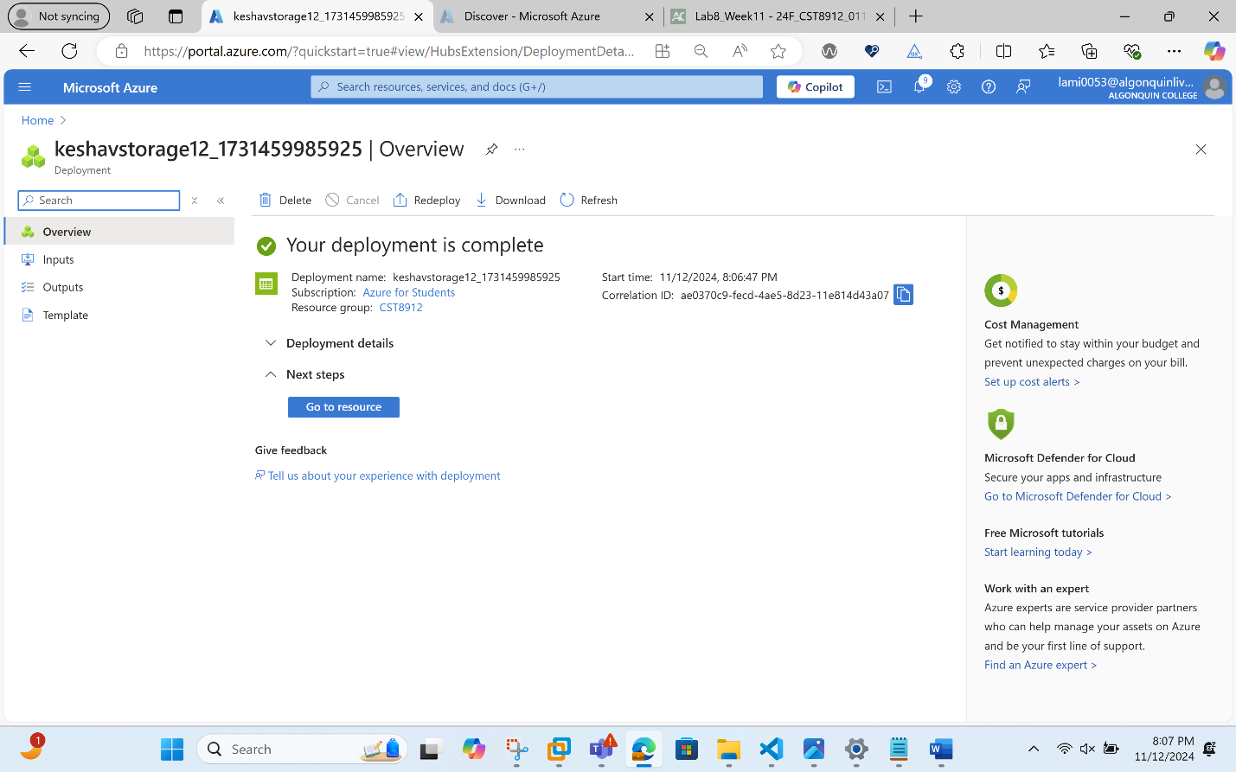
- On the Tags blade, note that the tag Cost Center with the value 000 has been automatically assigned to the resource.
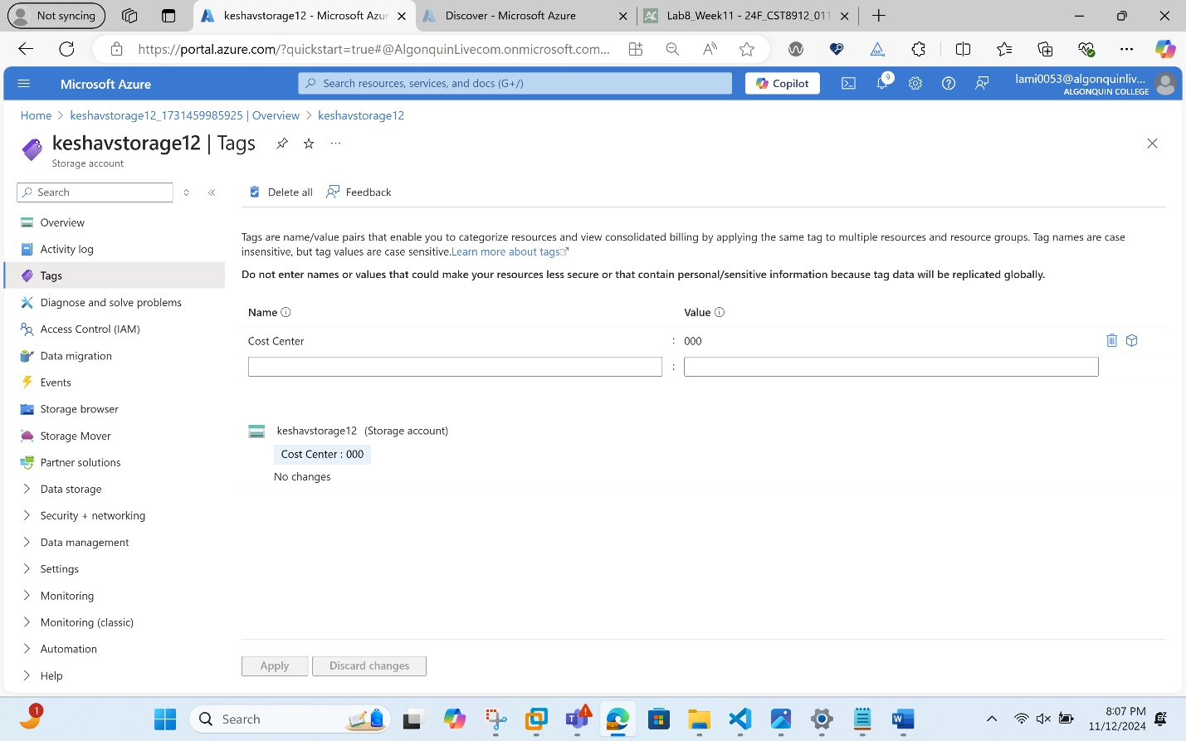
Task 4: Configure and test resource locks
- Search for and select your resource group.
- In the Settings blade, select Locks.
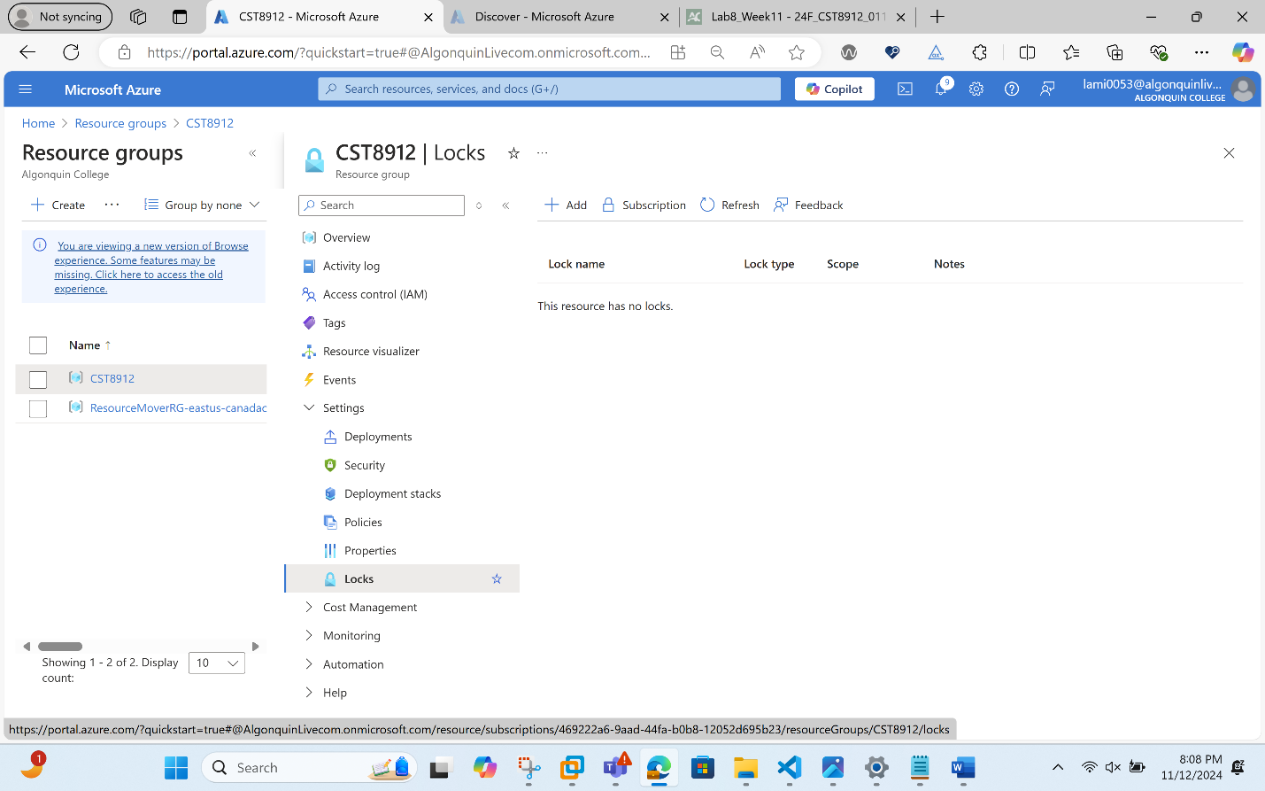
- Select Add and complete the resource lock information. When finished select Ok.
Setting | Value
Lock name | rg-lock
Lock type | delete (notice the selection for read-only)

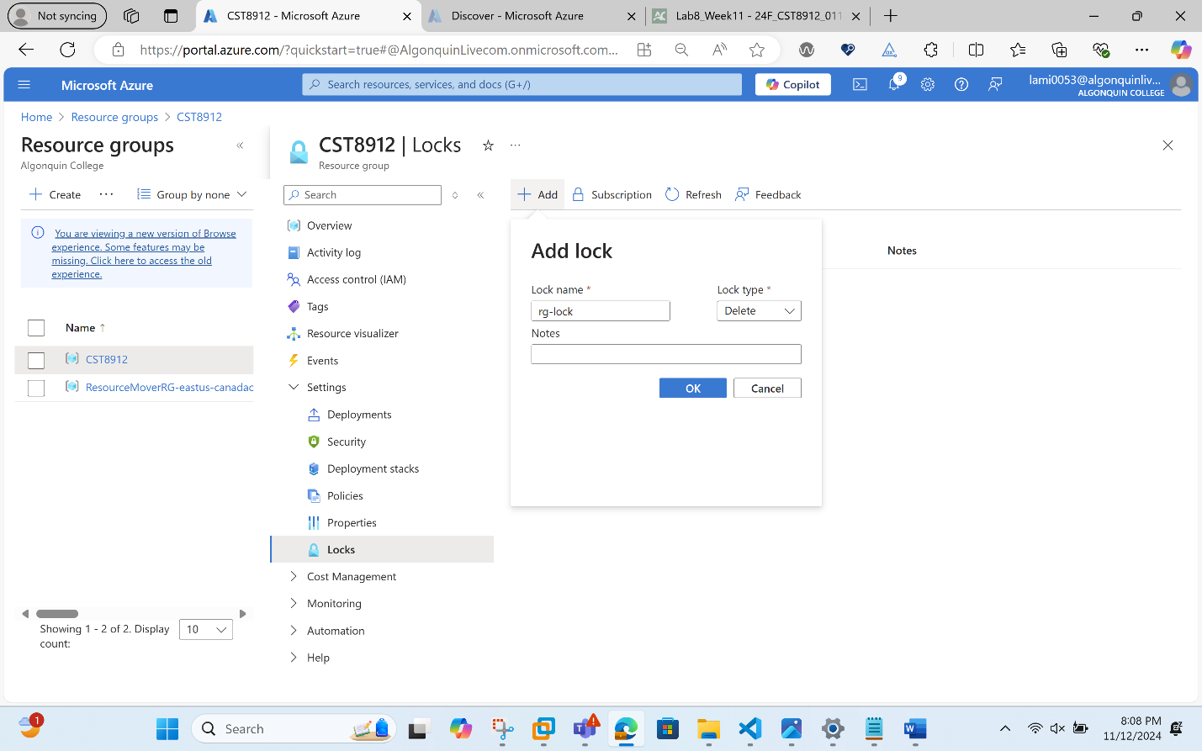
- Navigate to the resource group Overview blade, and select Delete resource group.
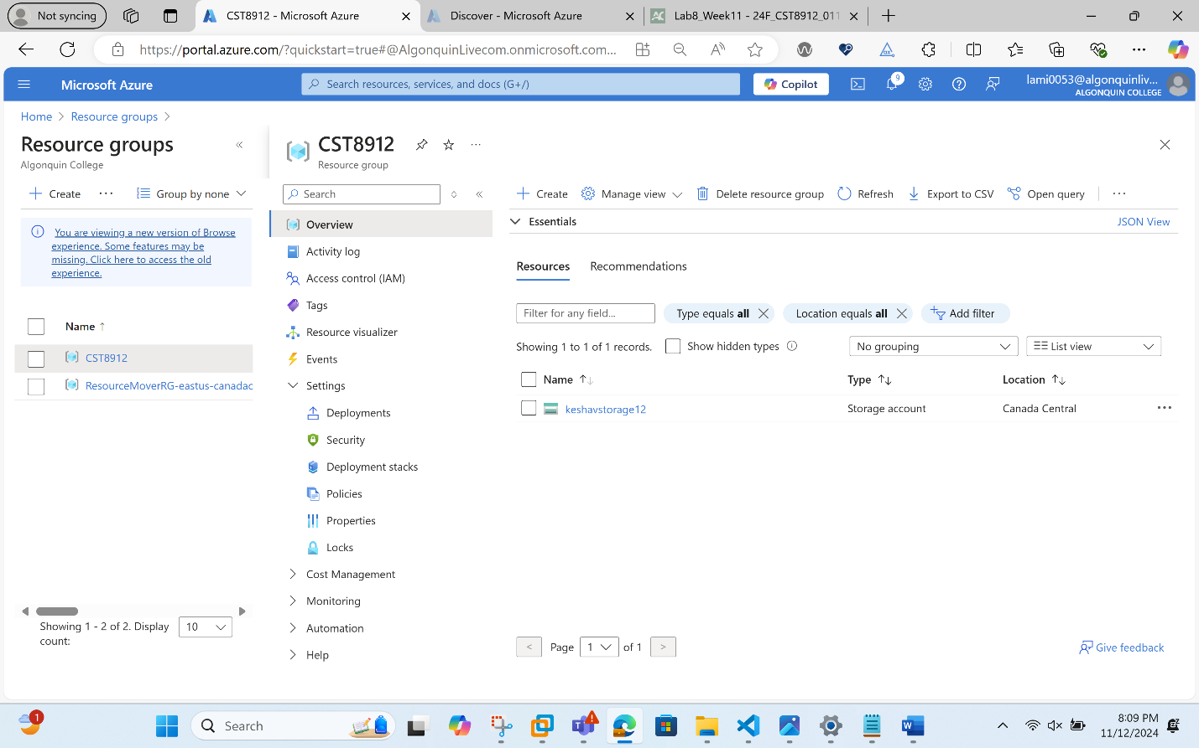
- In the Enter resource group name to confirm deletion textbox provide the resource group name, cst8912. Notice you can copy and paste the resource group name.
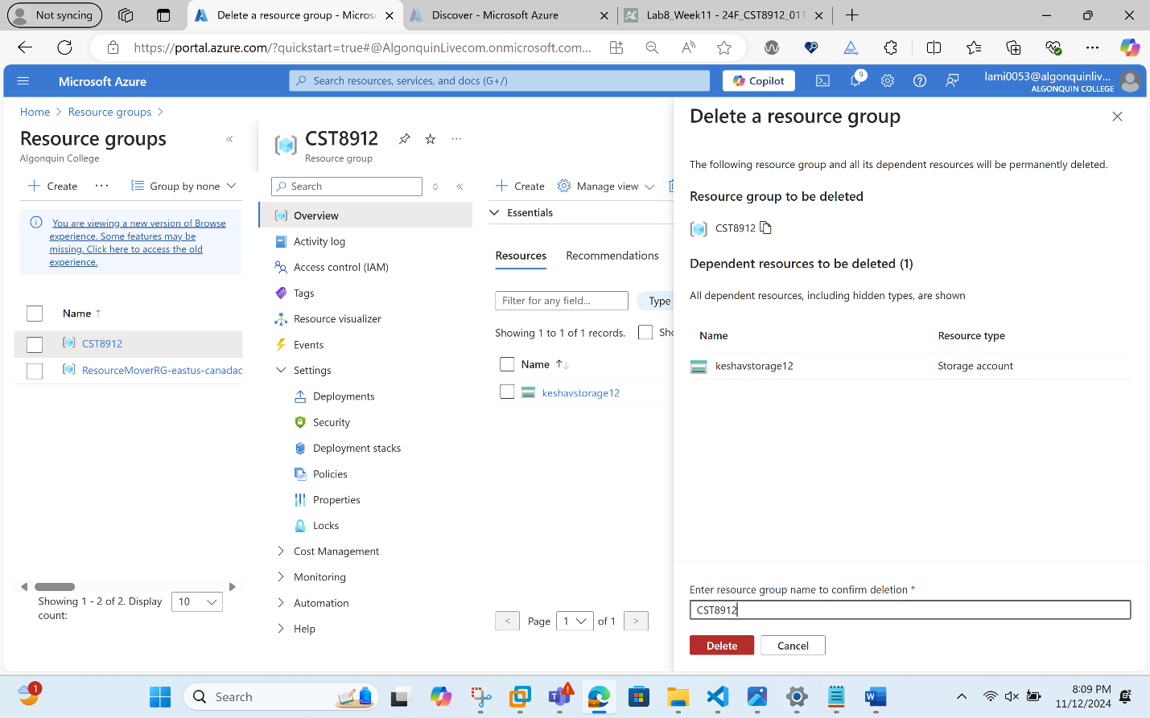
- Notice the warning: Deleting this resource group and its dependent resources is a permanent action and cannot be undone. Select Delete. You should receive a notification denying the deletion.
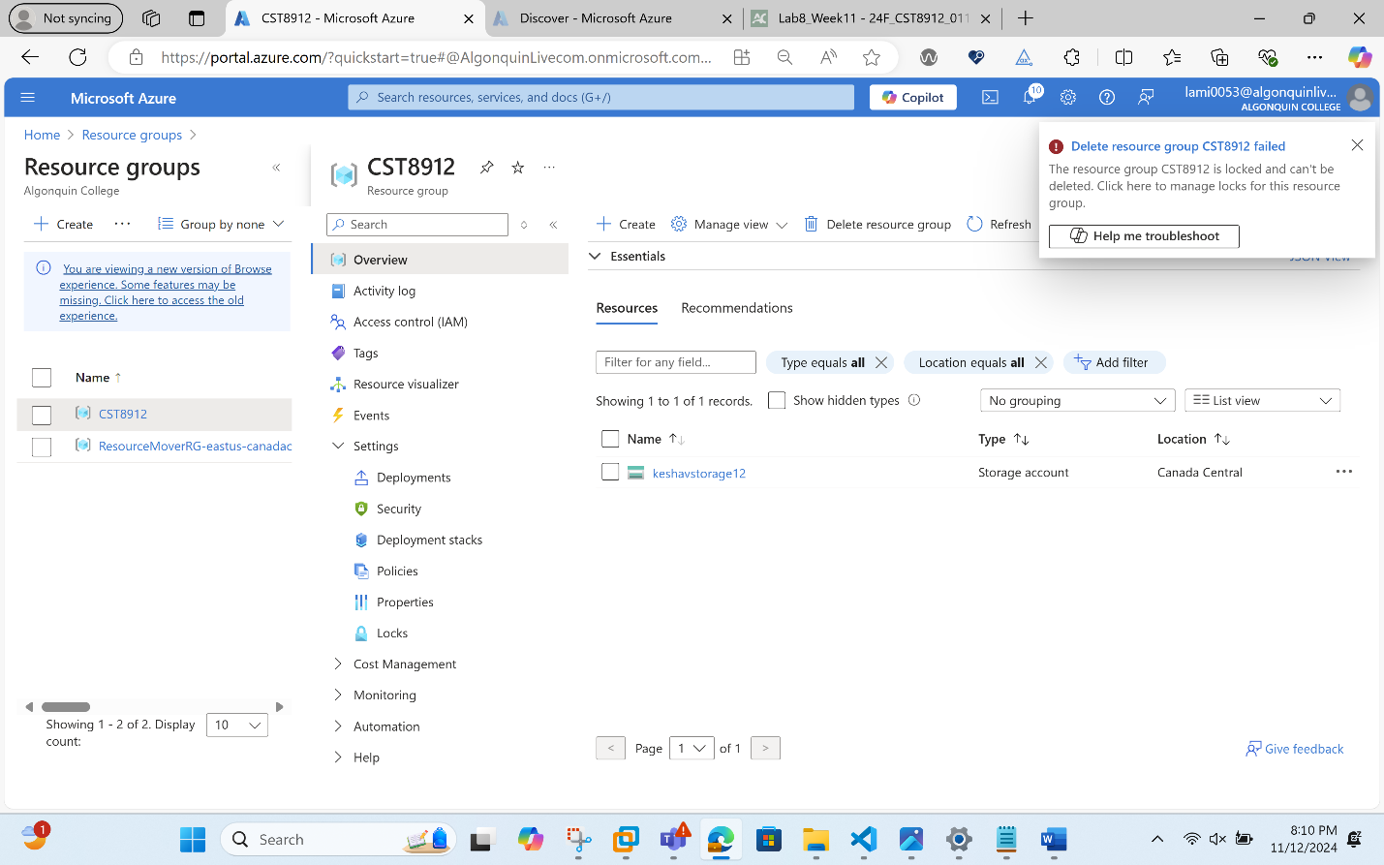
Task 5: Clean up the resources
- In the portal, search for and select Policy.
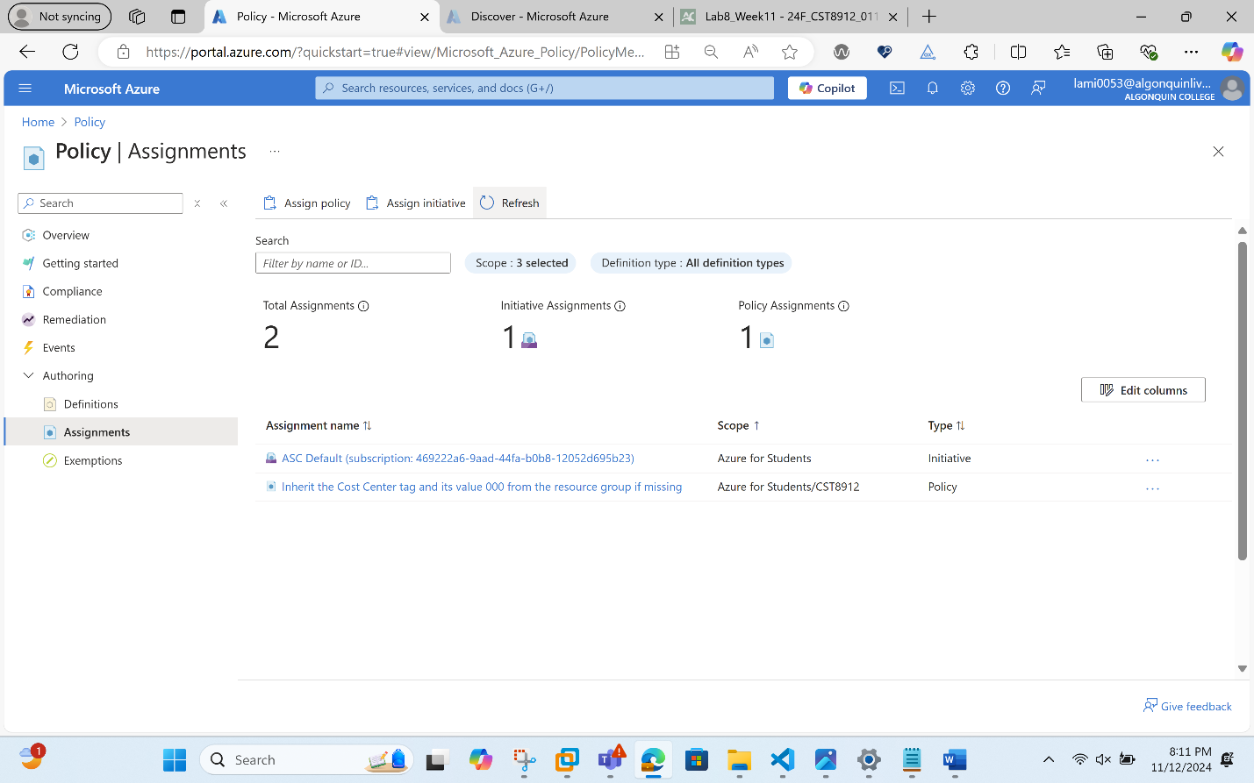
- In the Authoring section, click Assignments, click the ellipsis icon to the right of the assignment you created in the previous task and click Delete assignment.
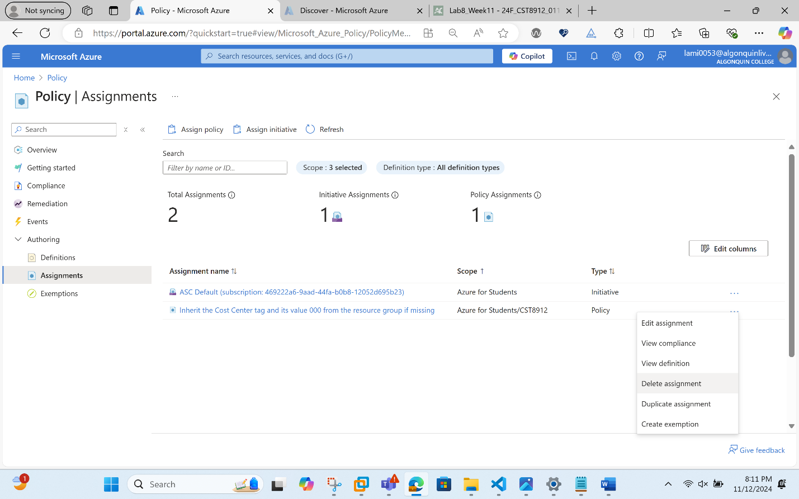
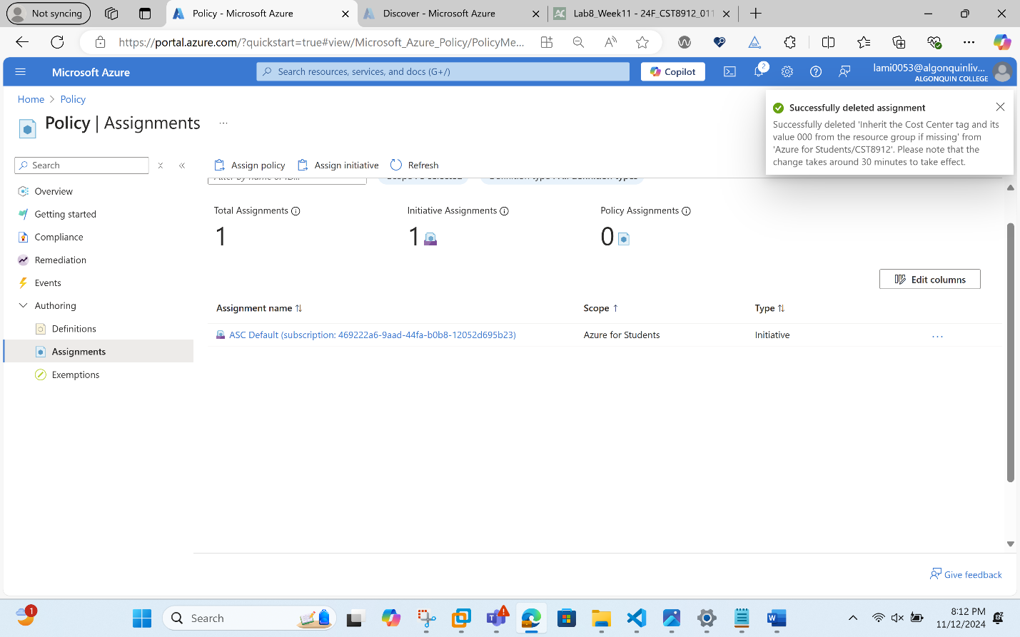
Note: The above assignment can only be deleted once the Locks are deleted as shown below we don’t have any locks.
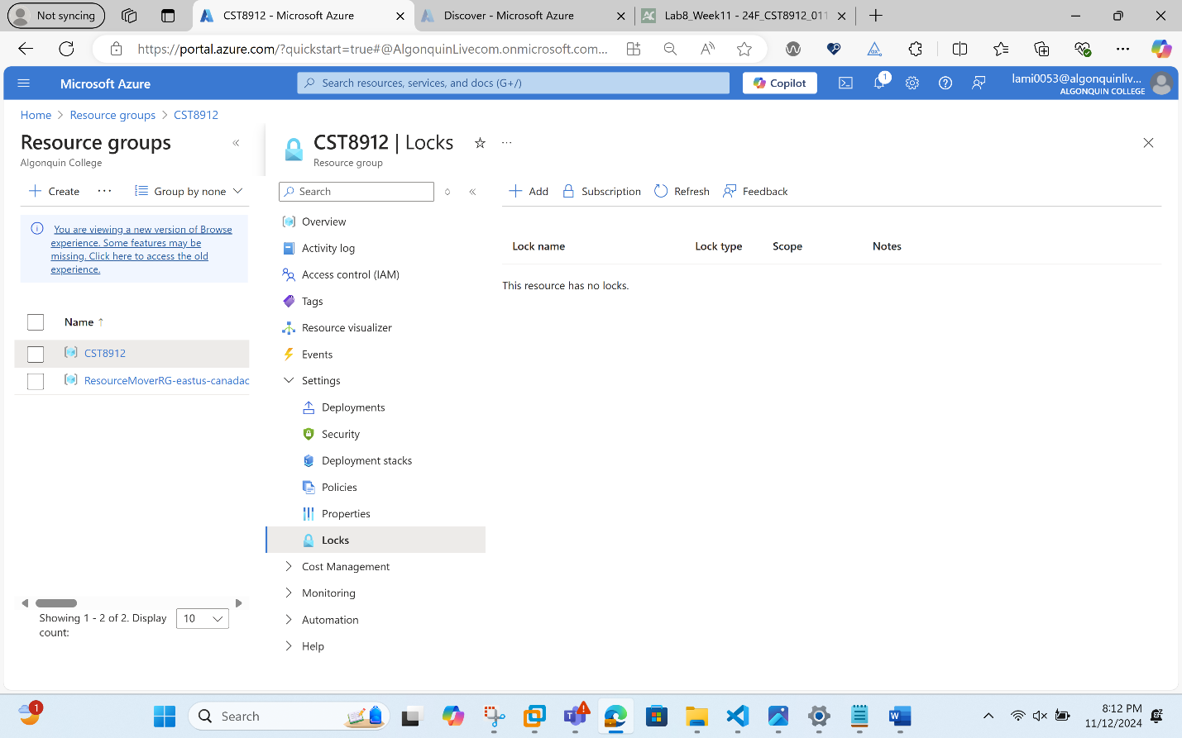
- In the portal, search for and select Storage accounts.
- In the list of storage accounts, select the resource group corresponding to the storage account you created in the last task of this lab. Select Tags and click Delete (Trash can to the right) to the Role:Infra tag and press Apply.
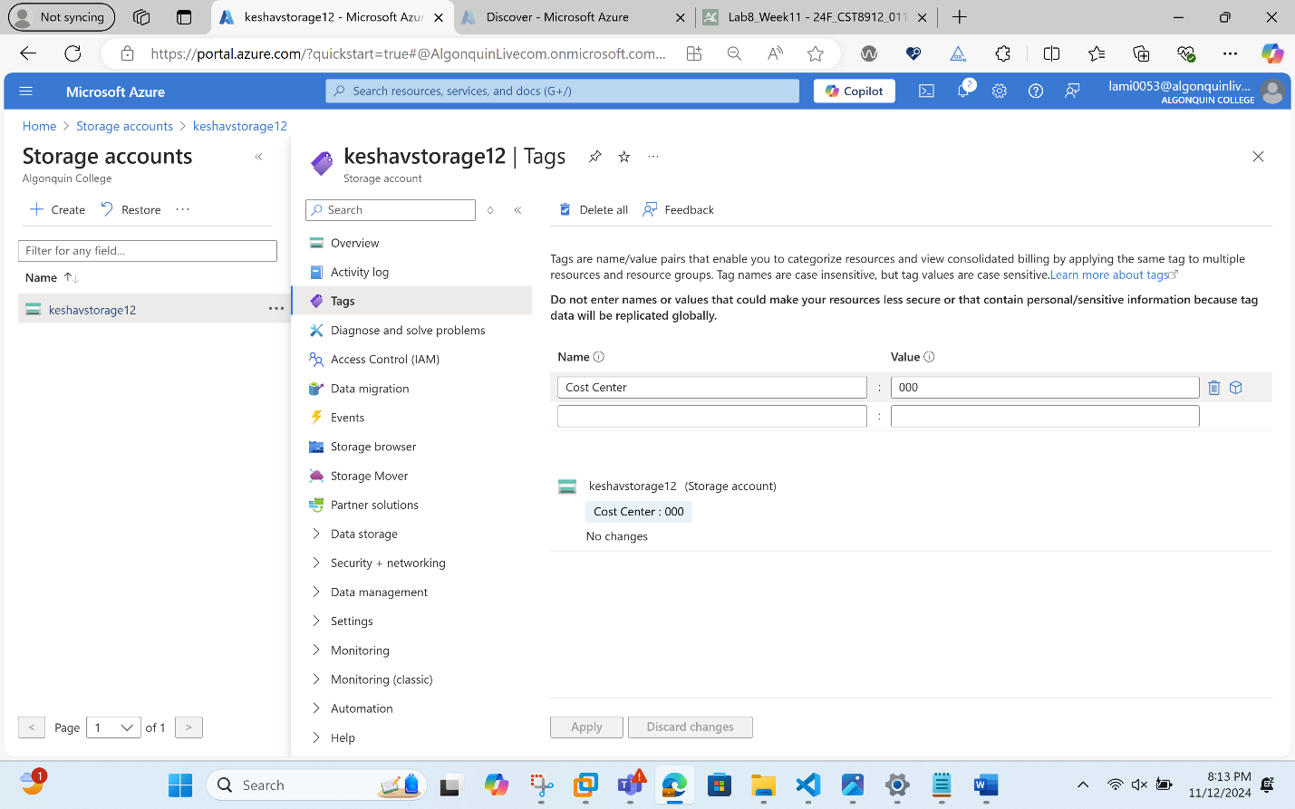
In this step we deleted the Tags.
- Click Overview and click Delete on the top of the storage account blade. When prompted for the confirmation, in the Delete storage account blade, type the name of the storage account to confirm and click Delete.
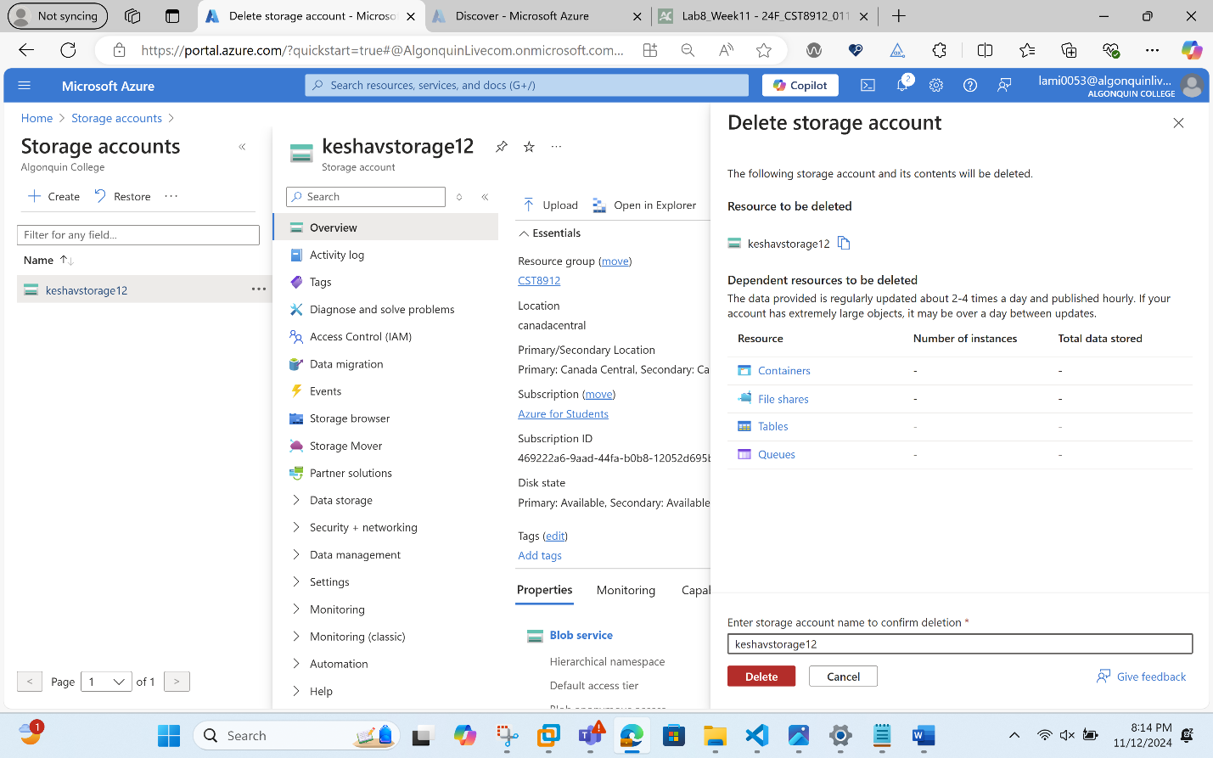
Finally, we deleted the resource group. And this completes the lab.
